ERCHONIA LUNULALASER™

A Retrospective Evaluation of the Effect of the
Erchonia LUNULALASER™ on the
Increase of Clear Nail in
Patients with Toenail Onychomycosis

ERCHONIA CORPORATION

Version 1.0
September 29, 2015
TABLE OF CONTENTS
STUDY INFORMATION 1
SPONSOR 1
CLINICAL CONSULTANT 1
REGULATORY CONSULTANT 1
PRINCIPAL CLINICAL INVESTIGATOR & TEST SITE 1
IRBs AND ETHICS COMMITTEE 1
PURPOSE OF STUDY 2
INDICATION FOR USE 2
FDA RESOURCES UTILZED AND REGULATORY HISTORY 2
DEVICE INFORMATION: ERCHONIA LUNULALASER™ 3
STUDY INDICATION AND RATIONALE, THEORY OF MECHANISM OF OPERATION & SUPPORTING MATERIALS 11
STUDY DESIGN 19
SAMPLE 19
STUDY PHOTO SET SELECTION 19
PRIVACY AND CONFIDENTIALITY 21
STUDY INVESTIGATOR 22
BLINDING AND RANDOMIZATION 22
STUDY PROCEDURE 24
STUDY MEASUREMENT TOOL: THE GNU MANIPULATION PROGRAM (GIMP 2.8)
24
MEASUREMENT METHODOLOGY 27
STATISTICAL ANALYSIS PLAN 28

APPENDICES
APPENDIX A: ESTABLISHMENT OF NON-SIGNIFICANT RISK
APPENDIX B: GIMP 2.8 SOFTWARE VALIDATION STUDY PROTOCOL
APPENDIX C: GIMP 2.8 SOFTWARE VALIDATION STUDY RESULTS
APPENDIX D: GIMP 2.8 MEASUREMENT METHODOLOGY INSTRUCTION SHEET
APPENDIX F: EVALUATOR CODED PHOTOGRAPH KEY
APPENDIX G: EVALUATOR PHOTOGRAPH MEASUREMENT RECORD FORM

STUDY INFORMATION

SPONSOR
Erchonia Corporation
2021 Commerce Drive
McKinney, TX 75069
Contact: Mr. Steven Shanks, President
Telephone: 214-544-2227
e-mail: sshanks@erchonia.com

CLINICAL CONSULTANT
Regulatory Insight, Inc.
Nashville Office
1503 Red Oak Drive
Brentwood TN 37027
Contact: Elvira Walls, Clinical Consultant
Telephone: 615-712-9743
e-mail: elvira@reginsight.com

REGULATORY CONSULTANT
Regulatory Insight, Inc.
Denver Office
33 Golden Eagle Lane
Littleton CO 80127
Contact: Kevin Walls, Principal Consultant
Telephone: 720-962-5412
e-mail: kevin@reginsight.com

PRINCIPAL CLINICAL INVESTIGATOR & TEST SITE
Kerry Zang, DPM
Arizona Institute of Footcare Physicians
1620 S. Stapley Dr., Suite 132
Mesa, AZ 85204
Telephone: 480-834-8804
e-mail: kerryzang@aol.com

INSTITUTIONAL REVIEW BOARDS & ETHICS COMMITTEE
As this is a retrospective study using existing digital photographic images taken during the execution of prior Erchonia Corporation clinical trials wherein subjects had provided written consent to the taking and use of his or her toenail photos for research purposes, IRB approval for this current retrospective study was not needed. The prior IRB and Ethics Committee approvals under which consent for the photographic image documentation and their evaluation for research purposes was provided are the following:

- Western Institutional Review Board® (WIRB®)
3535 Seventh Avenue, SW
OIympia, WA 98502-5010
Telephone: 360-252-2500
Fax: 360-252-2498
Approval #s : 20110461 ; 20121330 ; 20130029

- Saint Alphonsus IRB

SARMC Department of Research Integrity

055 N. Curtis Road

Boise, ID 83706

Telephone: 208-367-2233

Fax: 208-367-6821

www.sarmc.org

- Institute of Chiropodists and Podiatrists (Ireland) Ethics Board
22 New Cork Road, Midleton
Co. Cork, Ireland

Approval #: LLNS/RS0312

PURPOSE OF STUDY
The purpose of this study is to demonstrate through retrospective analysis the efficacy of the Erchonia LUNULALASER™, manufactured by Erchonia Corporation, for the increase of clear nail in patients with toenail onychomycosis, when applying the LUNULALASER™ to the toenail for 12 minutes one time per week for a total of 4 procedure administrations.

Erchonia Corporation intends to submit the data and analysis from this retrospective analysis via a 510(k) application to obtain FDA clearance to market the laser device for the below intended indication.

INDICATION FOR USE
The results of this retrospective analysis will be used to support the following indication for use statement: “The Erchonia LUNULALASER™ device is indicated for use for the temporary increase of clear nail in patients with onychomycosis (e.g., dermatophytes Trichophyton rubrum and T. mentagrophytes, and/or yeasts Candida albicans, etc.).”
STUDY BACKGROUND
The current study protocol is a retrospective evaluation of a sampling of study toenails drawn from across the three following independent clinical trials, each conducted under the approval of one or more of the IRB and/or Ethics Committees listed above. Each of the protocols had undergone review by the Food and Drug Administration (FDA) prior to execution of the respective trial:

- An Evaluation of the Effect of the Erchonia FX-405™ on Treating Toenail Onychomycosis Clinical Study; Version 3.0, March 10, 2011 (WIRB Protocol Approval #20110461)

- An Evaluation of the Effect of the Erchonia LunulaLaser™ on Treating Toenail Onychomycosis Clinical Study; Version 6.0, August 7, 2012 (WIRB Protocol Approval #20121330)

- An Evaluation of the Effect of the Erchonia LunulaLaser™ on the Temporary Increase of Clear Nail in Patients with Toenail Onychomycosis Clinical Study Protocol 2; Version 7.0, December 27, 2012 (WIRB Protocol Approval #20130029; Institute of Chiropodists and Podiatrists (Ireland) Ethics Board Approval #: LLNS/RS0312)

Each of these clinical trials employed a comparable clinical trial protocol, including the same study qualification criteria, treatment administration protocol and baseline and measurement endpoint evaluations.

DEVICE INFORMATION: ERCHONIA LUNULALASER™

DEVICE DESCRIPTION AND SPECIFICATIONS

The Erchonia LunulaLaser™ that was employed in each of the clinical trials from which digital photographic images for evaluation in this retrospective study are drawn is a dual-diode laser of 635 nm and 405 nm wavelength. The light emitting diodes are manufactured by DLC and classified by the Center for Devices and Radiological Health (CDRH) as Class II laser diodes. The LunulaLaser™ is a portable floor device with an AC power adapter.

The LunulaLaser™ has the following specifications:

Power | 16.0-18.5mW for the 635nm diode  21.5-24.0mW for the 405nm diode
Wavelength | 635nm & 405nm
Waveform | Constant Wave (CW)
Energy Source | Dual diode collected then line dispersed (coherent)
Power Supply | 100-240 VAC 50/60 Hz
Energy Delivery | Portable floor device
Treatment Time | 12 minutes

The Erchonia LunulaLaser™ is shown in Figure 1 below:

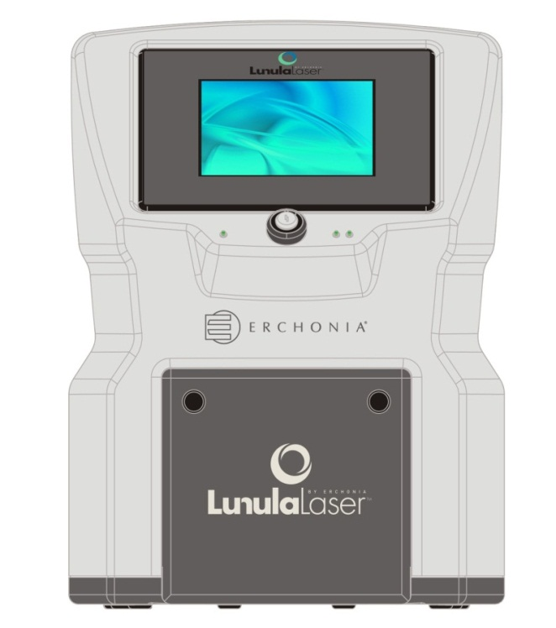
Figure 1: The Erchonia LunulaLaser™

DEVICE SYSTEM COMPONENTS

The individual system components of the Erchonia LunulaLaser™ are displayed in Figures 2, 3 and 4 below and labeled and described in the associated text.

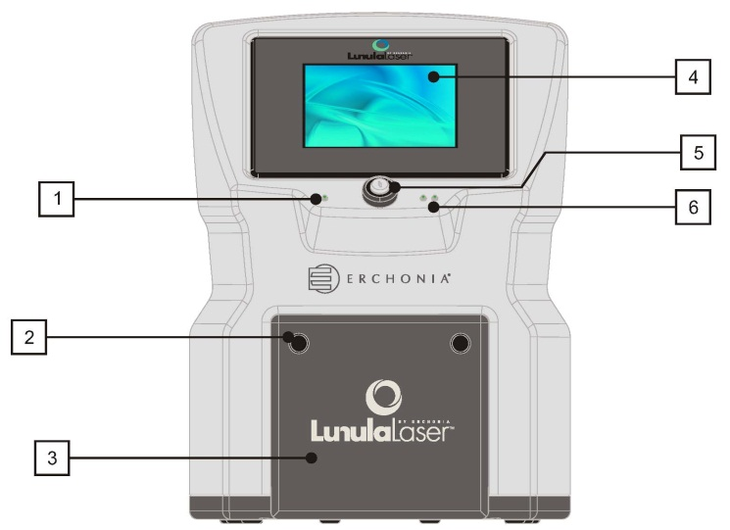
Figure 2: System components 1 through 6 of the Erchonia LunulaLaser™

- Power Indicator Light
- Pull Knobs / Stops
- Door / Foot Platform
- Touch Screen
- Key Switch
- Diode Light Indicator

1. Power Light Indicator: When the LunulaLaser™ is ON, the power light indicator shows GREEN. When the device is OFF, the LED is NOT lit.

2. Pull Knobs / Stops: On both sides of the door, there are protrusions that function as pull knobs when the door is closed. Pulling on these opens the door. Once the door is open, the protrusions function as stops, supporting the weight of the patient’s foot.

3. Door / Foot Platform: In the closed position (as shown on figure 2 above), this element is a door. The door / foot platform is multifunctional: when open, the inside of the door becomes the back half of the treatment platform.

4. Touch Screen: The touch screen functions as a display screen and an input panel, providing information to the user and a means to operate the device by touching the appropriate icon.

5. Key Switch: The key switch is the ON/OFF mechanism, shown as “O” = OFF and “I” = ON. When ‘ON,’ the power light indicator (item #1) will be lit.

6. Diode Light Indicator: When the device is ON and in treatment, these lights are lit, showing that each diode is emitting device light.

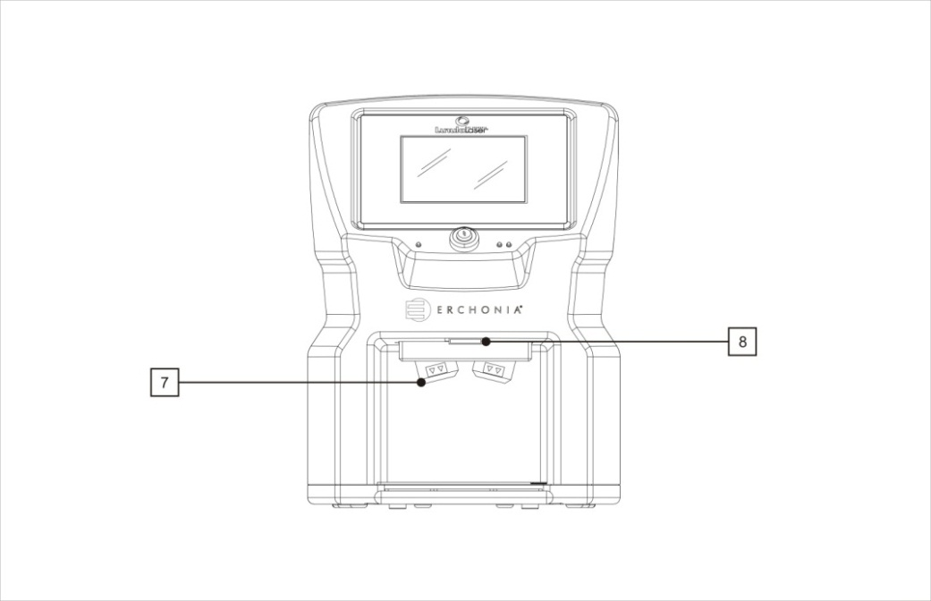
Figure 3: System components 7 and 8 of the Erchonia LunulaLaser™

- Laser Output Heads
- Magnetic Latch

7. Laser Output Heads: Each one of the two output heads emits laser light: one light is a 405nm violet beam and the other light is a 635nm red beam.

8. Magnetic Latch: The Door / Front Platform is held in the closed position by this magnetic latch.

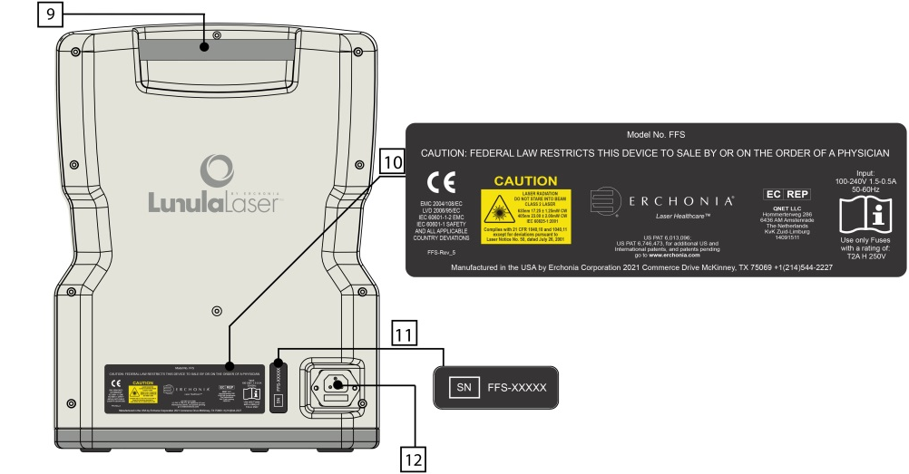

Figure 4: System components 9 through 12 of the Erchonia LunulaLaser™

9. Handle
10. Compliance Label
- Serial Number
- Power Inlet / Fuse Holder

9. Handle: The handle enables the user to pick up, carry and / or move the device with ease.

10. Compliance Label: Contains all the governing agencies required information regarding the device, including but not limited to the US FDA device classification, EU classification, output information and power inlet symbols. Also includes the manufacturer name and address (shown in Figure 5 below).

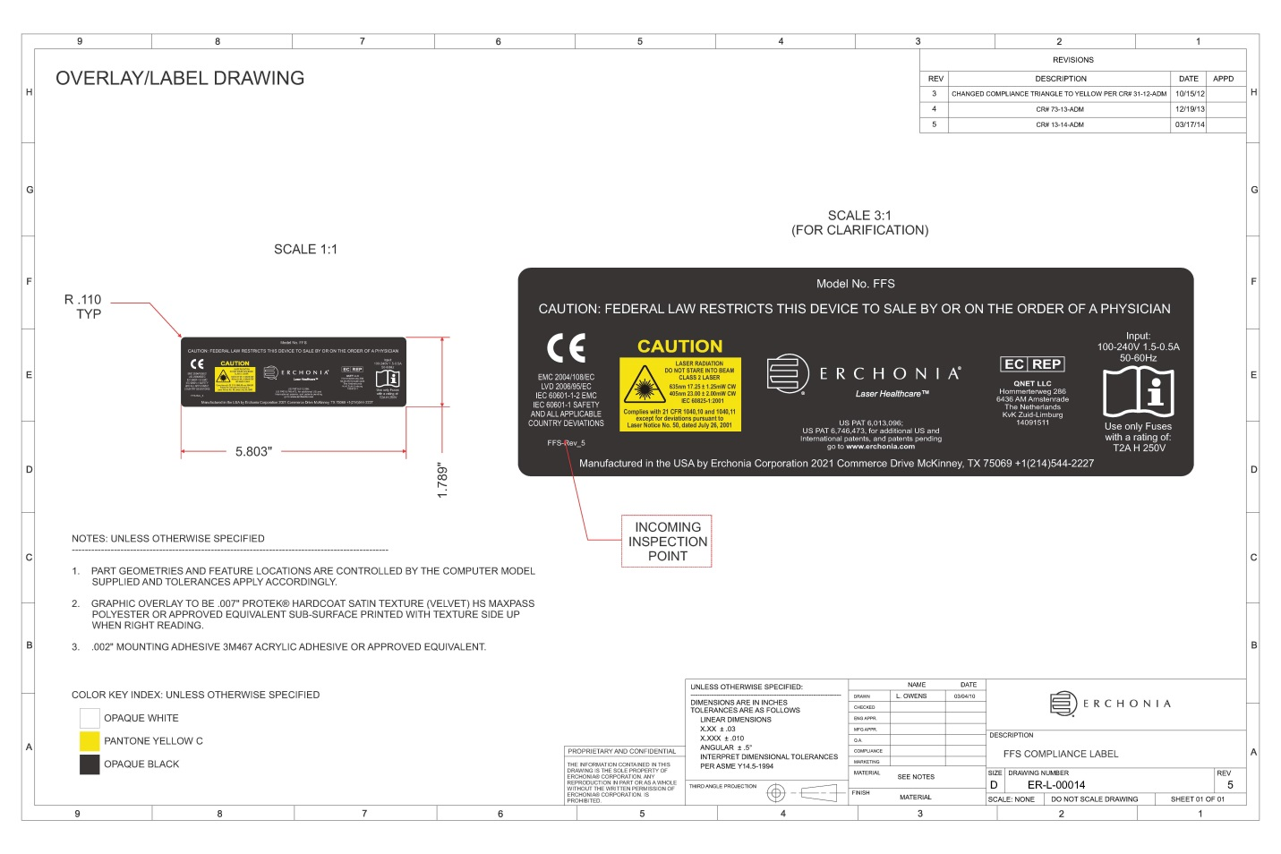

Figure 5: Compliance Label

11. Serial Number: This is the unique identifier for the device. All information regarding this device is associated with the serial number.

12. Power Inlet Module / Fuse Holder: The device contains a flexible detachable power cord. TNOTE: Make sure the power cord is plugged into the device at this location prior to plugging it into a wall socket. The power cord does not contain any operator-serviceable components. The power inlet module also contains a fuse holder. Replacing the fuses is the only service that can be conducted by the end-user. Fuses to be rated a T2AL 250V with an input to cover 100 – 240V~ 1.5-.5A, 50-60 Hz.

PROTECTIVE EYEWEAR

The Erchonia LunulaLaser™ is classified by the FDA/IEC as a Class 2 laser device. This designation represents a current standard for use in order to ensure the safety of the patient. A Class 2 laser is determined to have a chronic viewing hazard. Pointing the laser beam directly into the eye and maintaining it there for an extended period of time could prove to be damaging.

To ensure there was no possible instance of residual effect, a pair of specialty glasses (shown in Figure 6 below) was provided for use during in-office procedure applications with the Erchonia LunulaLaser™ laser device in all referenced clinical trials. These safety glasses are Kentek Corporation Filter #6101 light blue glasses with approximate VLT 63% that sufficiently and effectively block the laser light spectrum of the LunulaLaser™ laser device as follows: 405nm (OD 1.22) & 635nm (OD 2.07).

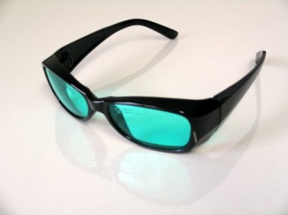

Figure 6: Kentek Corporation Filter #6101 Safety Glasses

Complete device details and safety profile is contained in Appendix A: Establishment of Non-Significant Risk, of this retrospective analysis protocol.

STUDY INDICATION AND RATIONALE, THEORY OF MECHANISM OF OPERATION, & SUPPORTING MATERIALS

STUDY INDICATION: TOENAIL ONYCHOMYCOSIS

Definition
An infection of toenail fungus, or onychomycosis, occurs when fungi infect one or more nails. A nail fungal infection may begin as a white or yellow spot under the tip of the toenail. As the nail fungus spreads deeper into the nail, it may cause nail discoloration, thickening and the development of crumbling edges, all of which can lead to an unsightly and potentially painful problem. Onychomycosis may be difficult to treat, and infections may recur easily. Toenail fungus affects approximately 23 million people in the US – about 10% of all adults.

Symptoms

The primary symptoms of onychomycosis are nails that are:
- thickened
- brittle, crumbly or ragged
- distorted in shape
- dull, lacking luster or shine
- a dark color, caused by debris building up under the nail

Additional symptoms may include:
- separation of the nail from the nail bed (onycholysis)
- pain in the toes
- slightly foul odor

Causes
Fungi are microscopic organisms that don't need sunlight to survive. Nail fungal infections are typically caused by a fungus that belongs to a group of fungi called dermatophytes, but may also be caused by yeasts and molds.

All of these microscopic organisms live in warm, moist environments, including swimming pools and showers. They can invade the skin through tiny invisible cuts or through a small separation between the nail and the nail bed. They cause problems only if the nails are continually exposed to warmth and moisture — conditions perfect for the growth and spread of fungi.

Infection with nail fungus occurs more commonly in toenails than in fingernails because toenails are often confined in a dark, warm, moist environment inside shoes — where fungi can thrive. Another reason may be the diminished blood circulation to the toes as compared with the fingers, which makes it harder for the body's immune system to detect and eliminate the infection.

Risk factors
- Onychomycosis is more common among older adults for several reasons, including diminished blood circulation and more years of exposure to fungi. Also, nails may grow more slowly and thicken with age, making them more susceptible to infection.
- Onychomycosis tends to affect men more often than it does women, particularly those with a family history of the infection.

- Other factors that can increase the risk of developing nail fungus include:
- perspiring heavily
- working in a humid or moist environment
- having the skin condition psoriasis
- wearing socks and shoes that hinder ventilation and don't absorb perspiration
- walking barefoot in damp public places, such as swimming pools, gyms and shower rooms
- having athlete's foot (tinea pedis)
- having a minor skin or nail injury, a damaged nail or another infection
- having diabetes, circulation problems or a weakened immune system

Potential Complications
The potential complications of onychomycosis include:
- pain in the nails
- permanent damage to the nails
- leading to other serious infections that can spread beyond the feet for individuals with a suppressed immune system due to medication, diabetes or other conditions, such as leukemia and AIDS
- For diabetes patients in particular, toenail onychomycosis can lead to impairment of the blood circulation and nerve supply to the feet and a greater risk for cellulitis, a potentially serious bacterial skin infection

Current Available Treatments
Nail fungus can be difficult to treat, and repeated infections are common. The currently available treatments for onychomycosis are the following:

- Oral antifungal medications: Oral antifungal medications such as terbinafine (Lamisil) and itraconazole (Sporanox) help a new nail grow free of infection, thereby slowly replacing the infected portion of the nail typically over a 6 to 12 week period. Recurrent infections are possible, and side effects range from skin rashes to liver damage.

- Antifungal lacquer: The antifungal nail polish ciclopirox (Penlac) for mild to moderate onychomycosis is painted onto the infected nails and surrounding skin once a day. After seven days, the piled-on layers are wiped clean with alcohol and fresh applications are begun. Daily use of Penlac for about one year can help clear some nail fungal infections.

- Topical medications: Topical over-the-counter antifungal creams containing urea can help speed up absorption, and while they usually don't provide a cure, they may be used in conjunction with oral medications to enhance the efficacy of oral medications.

- Surgery: For severe or extremely painful nail infections, the nail may be surgically removed. A new nail will usually grow in its place, though re-growth is slow and may take up to a year to grow back completely. Sometimes surgery is used in combination with ciclopirox to treat the nail bed.

- Photodynamic therapy: A laser is applied to irradiate the nail after treatment with an acid.

Laser Therapy as a Treatment for Toenail Onychomycosis
There is no perfect cure for toenail fungus. Even the most effective oral medications are successful only about half of the time. Topical medications are successful less than 10% of the time. As 10% of the adult population is affected by toenail onychomycosis, the need for a more effective and lasting cure is evident. Recently, research has found laser therapy to show promise as a novel alternative treatment for toenail onychomycosis. Unlike medication-driven treatments for toenail fungus which can have many side effects including serious ones such as liver toxicity, laser therapy presents minimal to no risk of side effects. Laser therapy is applied to toenail onychomycosis by shining a laser light through the toenail into the tissue below. The laser light vaporizes the fungus while leaving the skin and surrounding healthy tissue unharmed.
To date, the FDA has cleared several 1064nm YAG and 980nm laser devices for the following indication for use; “For the temporary increase of clear nail in patients with onychomycosis (e.g., dermatophytes trichophyton rubrum and t. mentagrophytes, and/or yeasts candida albicans, etc.),” under Classification Product Code PDZ.

The Erchonia Corporation LUNULALASER™ provides comparable results to those attained with YAG lasers, but at much lower wavelengths and lesser outputs, and therefore reduced potential risks and side effects.

THEORY OF MECHANISM OF OPERATION OF THE APPLICATION OF LLLT TO TREATING TOENAIL ONYCHOMYCOSIS
Onychomycosis (OM) is the term used to classify a fungal infection of toenails and/or fingernails. The infection may encompass any single component of the nail, including the nail bed, nail plate, or the nail matrix. Common side effects of OM include pain, discomfort, and disfigurement and may produce serious physical and occupational limitations. A disorder such as OM may have a detrimental effect on an individual’s quality of life, affecting their psychosocial and emotional well-being. The main subtypes of OM are distal lateral subungual OM (DLSO), white superficial OM (WSO), proximal subungual OM (PSO), endonyx OM (EO), and candidal OM. Patients may have a combination of these subtypes. Total dystrophic OM refers to the most advanced form of any subtypee.

The most common form of OM is DLSO, a condition where the fungus spreads from plantar skin and progresses towards the underside of the nail through the hyponychium or the distal lateral nail bed. An inflammatory response is quickly upregulated in the area of infection, generating the physical signs of DLSO. The onset of fungal infection is caused by three main classes of fungi: dermatophytes, yeasts, and nondermatophyte molds. The most common cause of OM worldwide is due to the infection of dermatophytes, including the genera Epidermophyton, Microsporum, and Trichophyton. There are two major pathogens that account for a majority of OM cases, T rubrum and Trichophyton mentagrophytes. The risk factors leading to the onset of OM include family history, increasing age, poor health, prior trauma, warm climate, participation in fitness activities, immunosuppression, communal bathing, and occlusive footwear.

The treatment options for clinicians has improved drastically over the years; however, the rate of recurrence still remains high, and the costs and risks involved may be steep for some patients. However, a new and innovative technology, low-level laser therapy, has slowly begun to acquire a high level of interest across a myriad of medical disciplines. Laser therapy operates under the principle of photochemistry with a photoacceptor molecule absorbing the emitted photons and inducing a biological cascade. Like our eukaryotic cell, fungi contain the highly complex organelle the mitochondria, which is responsible for the manufacturing of the energy molecule ATP. Within the inner mitochondrial membrane is cytochrome c oxidase, an identified photoacceptor molecule. It is believed that laser therapy could perhaps provide a means to photo-destroy the fungi responsible for OM by inducing the release of highly reactive superoxides. Moreover, laser therapy has been shown to promote superoxide dismutase (SOD), a process responsible for the destruction of foreign invaders. Extracellular release of low levels of mediators associated with SOD can increase the expression of chemokines, cytokines, and endothelial leukocyte adhesion molecules, amplifying the cascade that elicits the inflammatory response. The physiologic function of hydrogen peroxide, superoxide anion, and hydroxyl free radical is to destroy phagocytosed microbes. By enhancing the natural processes of the immune system and impacting the structural integrity of the fungi strain, it is believed that laser therapy may provide a means for clinicians to effectively treat OM without the onset of any adverse events.

The wavelengths that will be utilized in this study will be a violet (405nm) and red (635nm) combination. The wavelengths were chosen based on the theory of electron volt stimulation. When studying the light spectrum chart, there is an inverse relationship between wavelength and the individual energy level of the photon (electron volt). As we move towards lower wavelengths, the energy of the emitted photon increases; for instance, a radio wave has far less electron volts (energy per photon) than the photons of an x-ray. Within the visible light spectrum, the highest electron volt levels are observed towards the lower end of the spectrum, therefore greater biological stimulation can occur with a 400 nm and 635nm wavelength.

ERCHONIA CORPORATION CLINICAL TRIALS
Erchonia Corporation has conducted several clinical trials evaluating the efficacy of their low level lasers in increasing clear nail growth in patients with toenail onychomycosis.

These studies are listed chronologically, with the respective findings summarized, below:

- A Pilot Evaluation of the Application of the Erchonia LUNULA™ for the Treatment of Onychomycosis; December, 2010

STUDY SAMPLE: In this pilot evaluation, 168 right and left onychomycosis-infected toenails were treated with the active Erchonia LUNULA™ laser in the study. Subjects were predominantly Caucasian of average age of 59.3 years. Two-thirds of the subject sample were female.

The average duration of toenail fungus disease at study baseline was 8.19 years.

The per cent (%) nail involved with onychomycosis at baseline ranged from 20% to 100%, and average 81.15%.

TREATMENT PROTOCOL: Each study toenail received 10-minute treatment administration session with the active Erchonia LUNULA™ Laser.

OUTCOME MEASURES: Treatment efficacy was evaluated as the % improvement in clear (non-involved) toenail from baseline to endpoint evaluation.

Endpoint evaluation varies across subjects and occurred anywhere from 2 to 13 months following laser procedure administration, with the average duration being 6.4 months.

RESULTS: The mean change in % nail involved with onychomycosis across the study evaluation period across all 168 toes combined was a decrease from 81.15% to 31.32% - a 63.58% improvement in clear (non-involved) nail from baseline to endpoint evaluation.

A two-sample t-test analysis for correlated samples found this change to be statistically significant at p<0.0001 (t=+27.94).

The changes were comparable across gender and right and left toes and across varying degrees of baseline % toenail onychomycosis involvement.

CONCLUSION: The LUNULA™ laser appears to be an effective tool for enhancing clear nail growth in onychomycosis-infected toenail over an average 6 month period.

- An Evaluation of the Effect of the Erchonia FX-405™ on Treating Toenail Onychomycosis Clinical Study Protocol; Version 3.0; March 10, 2011

BACKGROUND: The purpose of this clinical study was to demonstrate the efficacy of the Erchonia FX-405™, manufactured by Erchonia Corporation, for the treatment of onychomycosis of the toenail, by applying the Lunula™ to the affected toenail two times, each administration being seven days apart.

STUDY DESIGN: This clinical study was a single group (active treatment only) design.

SUBJECTS: One hundred and five (105) subjects completed this study. All 105 subjects received the active treatment with the study device. The majority of subjects were Caucasian, about 20% more females than males, and of average age 59.50 years. Average per cent (%) baseline toenail onychomycosis involvement was 57.39%. Average baseline mm clear nail bed was 4.60 mm.

STUDY PROCEDURE: Subjects received ten-minute active treatment administrations with the Erchonia FX-405™ to the onychomycosis-infected toenail, each procedure separated by seven days.

STUDY MEASURES: Measurement of mm of clear nail bed was recorded at baseline, 3 months and 6 months post final treatment administration; per cent (%) clear nail was recorded at baseline, 2 months, 3 months and 6 months post final treatment administration.

STUDY RESULTS

(i) Change in Per Cent (%) Clear Nail: The study primary outcome measure was the mean per cent (%) increase in clear nail at study end point relative to baseline measurement.

It was pre-determined that a subject would be considered an individual study success if his or her treated toenail attained at least a 25% increase in clear nail at study endpoint relative to baseline. Study endpoint was considered as 3 months after the final treatment administration with the Erchonia FX-635™ laser. It was pre-determined that at least 60% of subjects needed to demonstrate individual study success in order for the study to be considered a success.

Sixty-two per cent (62%) of subjects attained a 25% or greater increase in % clear nail at 3 months post final treatment administration compared with baseline, exceeding the overall study goal by 2%.

The mean per cent (%) change in clear nail across the evaluation period was +30.36%.
A t-test for paired samples revealed this increase in % clear nail to be statistically significant at p<0.0001

Chart 1 below illustrates the mean change in % clear nail across the 3 evaluation points

% Clear Nail
Baseline
2 Months
3 Months

ANOVA analysis for 3 correlated samples found the changes in mean % clear nail across the 3 evaluation points to be statistically significant at p<0.0001. Subsequent Tukey HSD Test analysis found the changes between each of the 3 evaluation points to be statistically significant at p<0.01.

(ii) Change in mm Clear Nail Bed: Mean mm clear nail bed increased 4.99 mm (from 4.6 mm to 9.59 mm) from baseline to 3-month post-procedure endpoint evaluation. A t-test for paired samples revealed this mean change to be statistically significant at p<0.0001.

ADVERSE EVENTS: No adverse event occurred for any subject throughout the duration of the clinical study.

CONCLUSION: The Erchonia FX-635™ is an effective tool for treating toenail onychomycosis, significantly promoting progressive clear nail growth over a 3-month period when applied to the affected toenail.

- An Evaluation of the Effect of the Erchonia LUNULA™ on the Temporary Increase of Clear Nail in Patients with Toenail Onychomycosis Clinical Study Protocol 2; Version 7.0, December 27 2012

BACKGROUND: The purpose of this clinical study was to demonstrate the efficacy of the Erchonia LUNULA™, manufactured by Erchonia Corporation, for the treatment of onychomycosis of the toenail, when applying the LUNULA™ to the toenail for 12 minutes one time per week for 4 consecutive weeks, for a total of 4 treatment administrations.

STUDY DESIGN: This clinical study was a single site, single group (active procedure only) non-randomized non-blinded design.

STUDY MEASURES: Millimeter (mm) of clear (uninfected) nail bed and per cent (%) of toenail onychomycosis disease involvement were objectively and independently determined using topographical software digital photo-planimetry software and triangulation methodology translated to a clear linear measurement at baseline; at the end of the procedure administration phase, and at 12 weeks, 36 weeks and 48 weeks post-procedure administration end.

STUDY PROCEDURE: Study toenails received 4 procedure administrations with the active Erchonia LUNULA™ across a consecutive 3-week period: each procedure administration 7 days apart. Exposure time to the laser was 12 minutes directed at and about 4 inches above the toenail.

SUBJECTS AND SAMPLE: One hundred and nine (109) subjects – and 139 right and left toenails - completed the study. Subjects were Caucasian, 58% female, and of average age 41.75 years. Each toenail was determined positive for onychomycosis through lab testing.

Average duration of toenail onychomycosis at study entry was 25.97 months. Average percentage of toenail onychomycosis disease involvement at baseline was 63.21%. Average mm of clear nail from the lunula at baseline was 5.90 mm.

STUDY RESULTS

Primary Outcome Measure: Change in mm of Clear Nail from Baseline to Study Endpoint: The primary efficacy outcome measure in this study was pre-determined as the mm of clear nail growth at Week 36 post procedure administration end relative to Baseline (pre-procedure administration). Individual toenail success was defined as 3 mm or more of clear nail growth at 36 weeks relative to baseline. Overall study success was defined as an anticipated 60% of treated toenails meeting the individual toenail success criteria.

Ninety six per cent (96%) of all study treated toenails met the study individual toenail success criteria, exceeding the pre-established overall study success goal of 60% by 36%. The magnitude of the mean change in mm of clear nail from baseline to 36 weeks post-procedure evaluation for all treated toenails was an increase of 8.82 mm, 5.82 mm in excess of the pre-established 3 mm increase success criteria. A t-test for paired samples found this mean change to be statistically significant at p<0.0001 (t=-23.02).

Additional Measures:

      - Change in mm of Clear Nail Across Study Duration: Table 1 and Chart 1 below show the mean mm of clear nail across the five study evaluation points of baseline; week 4 (end of procedure administration phase); and week 12, week 36 (endpoint) and week 48 (follow-up evaluation) following procedure administration end.

Table 1: Mean mm clear nail across study Chart 1: Mean mm clear nail across study
duration duration

Evaluation Phase | mm clear nail
Baseline | 5.90
Week 4 | 9.63
Week 12 | 11.53
Week 36 | 14.26
Week 48 | 15.09

ANOVA analysis found that mean mm clear nail increased significantly across and between all 5 study evaluation points, indicating a progressive and cumulative treatment effect of the laser.

      - Change in % Onychomycosis Disease Involvement Across Study Duration: Table 2 and Chart 2 below show the mean % of toenail onychomycosis disease involvement across the 5 study evaluation points

Table 1: Mean % onychomycosis disease Chart 1: Mean % onychomycosis disease
involvement across study duration involvement across study duration

Evaluation Phase | % Disease
Baseline | 63.21
Week 4 | 37.72
Week 12 | 25.58
Week 36 | 8.06
Week 48 | 2.49

ANOVA analysis found that mean % toenail onychomycosis disease involvement decreased significantly across and between all 5 study evaluation points, indicating a progressive and cumulative treatment effect of the laser.

ADVERSE EVENTS: No adverse event was reported for any subject throughout study duration.
CONCLUSION: The Erchonia LunulaLaser™ is an effective tool for treating toenail onychomycosis and preventing re-infection, significantly and progressively increasing mm of clear nail and decreasing % onychomycosis disease involvement over a 48 week period following completion of the 4-week procedure administration phase.

STUDY DESIGN

SAMPLE
The sample in this retrospective study will comprise photographs of great toenails with varying degrees of onychomycosis disease involvement selected from amongst an existing pool of photographs taken during three prior research studies and for which the subjects have provided prior consent to permit the photographs to be taken and used for research purposes.

The prior IRB-approved clinical trials from which the sample for this retrospective analysis study will be drawn are the following:

- An Evaluation of the Effect of the Erchonia FX-405™ on Treating Toenail Onychomycosis Clinical Study; Version 3.0, March 10, 2011 (WIRB Protocol Approval #20110461)

- An Evaluation of the Effect of the Erchonia LunulaLaser™ on Treating Toenail Onychomycosis Clinical Study; Version 6.0, August 7, 2012 (WIRB Protocol Approval #20121330)

- An Evaluation of the Effect of the Erchonia LunulaLaser™ on the Temporary Increase of Clear Nail in Patients with Toenail Onychomycosis Clinical Study Protocol 2; Version 7.0, December 27, 2012 (WIRB Protocol Approval #20130029; Institute of Chiropodists and Podiatrists (Ireland) Ethics Board Approval #: LLNS/RS0312)

Sample Size
There will be an anticipated 50 great toenails from the above three prior clinical trials selected for evaluation in this retrospective study. For each of the 50 great toenails selected, there will have been one photograph taken at baseline evaluation (prior to treatment administration) and a second photograph taken at 6 months post treatment administration completion (study endpoint evaluation). Therefore, there will be about 50 subjects (toes) and 100 photos (one pre and post set per subject) evaluated in this retrospective study.

Rationale for sample size
The sample size of 50 subjects/toes was specified by the Food and Drug Administration’s Center for Devices and Radiological Health, Office of Device Evaluation, Division of Surgical, Orthopedic, and Restorative Devices, General Surgery Devices Branch as sufficient to demonstrate efficacy of the study treatment.

STUDY PHOTOGRAPH SET SELECTION

The photographic evaluation set to be analyzed in this retrospective study will be drawn from each of the three Erchonia Corporation sponsored clinical trials listed above to form a set of about 50 pre- and post-treatment digital images that contain an embedded mm reference scale in both the pre- and post-treatment digital images for the same toenail but are otherwise unmarked or unlabeled.

The selection criteria necessitating that an embedded mm reference scale be included in the digital photographic image is for measurement calibration purposes, as a sufficient visible mm reference scaling is necessary for scale calibration to be performed to apply the GNU Image Manipulation Program (GIMP 2.8) software measurement system, the measurement tool to be employed in this retrospective analysis study for primary outcome measure evaluation. In concordance with the U.S. FDA’s request, Erchonia Corporation conducted a validation study to validate application of the GNU Image Manipulation Program (GIMP 2.8) software system and associated methodology for the linear measurement of mm of clear nail from digital images.

The GNU Image Manipulation Program (GIMP 2.8) software measurement system validation protocol and results analysis is contained in Appendix B and C, respectively, of this retrospective analysis protocol document. The outcome was deemed acceptable by the U.S. Food and Drug Administration (U.S. FDA)

The study qualification criteria under which all toenails were enrolled in each of the above-listed clinical trials from which the sample for this current retrospective study will be selected is the following:

Inclusion Criteria
- Great toenail presents with clearly visually identifiable and photographically documentable onychomycosis of the great toenail, or no visible onychomycosis (1 great toenail)
- Onychomycosis has been identified as due to bacterial/fungal infection classified by the investigator as onychomycosis, with the nail presenting positive on visual inspection for somewhat thickened nail plate with a cloudy appearance and some discoloration (white to yellow to brown)
- Onychomycosis etiology has been confirmed through positive fungal KOH testing results

Exclusion Criteria
- The category of the presenting visible great toenail onychomycosis covers the ranges of: 0%-25% onychomycosis involvement; 26%-50% onychomycosis involvement; 51%-75% onychomycosis involvement; and 76%-100% onychomycosis involvement
- Spikes of disease extending to nail matrix in the great toenail
- Infection involving lunula of the great toenail, e.g. genetic nail disorders, primentary disorders
- Great toenail has less than 2mm clear (unaffected) nail plate length beyond the proximal fold
- Dermatophytoma or “yellow spike/streak” (defined as thick masses of fungal hyphae and necrotic keratin between the nail plate and nail bed) on the great toenail
- Onychogryphosis
- Proximal subungual onychomycosis
- White superficial onychomycosis

The treatment administration protocol administered to all toenails enrolled in each of the above-listed clinical trials from which the sample for this current retrospective study will be selected is the following:

- There were four in-office procedure administrations with the Erchonia LunulaLaser™ laser device, each one seven days apart.
- Each laser procedure was administered by the study investigator at the test site.
- The individual procedure administration protocol was as follows:

- The subject was seated comfortably with the LunulaLaser™ placed on the floor in front.
- The subject was fitted with the safety glasses.
- The subject placed the foot with the toenail to be treated on the treatment platform inside the Erchonia LunulaLaser™ device – heel on the back, toes on the front platform under the laser output heads, as shown in the figure below.
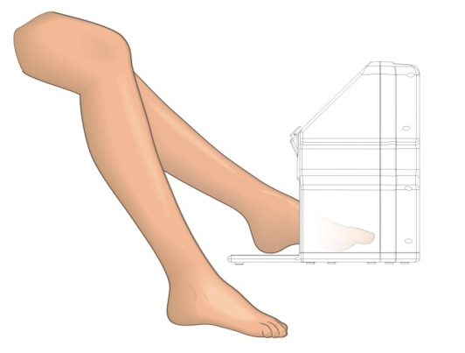
- The Erchonia LunulaLaser™ was activated such that the laser light was directed at the target toenail at a distance of approximately 4 inches above the toenail.
- The dual wavelengths of 405 nm and 635nm were activated simultaneously for 12 minutes of total procedure administration time.
- The subject removed his or her foot from the Erchonia LunulaLaser™.
- The laser procedure administration was then complete.
- The subject removed the safety glasses, and the procedure administration protocol was completed.

Subjects agreed to refrain from other non-study treatment(s) for toenail onychomycosis (including oral medications and nail lacquer, non-alternative therapies such as acupuncture and home remedies), or to use any toenail cosmetics throughout the course of study participation, and all complied with this requirement.

The evaluation time points for all toenails enrolled in each of the above-listed clinical trials from which the sample for this current retrospective study will be selected and evaluated are the following:

- Baseline (pre-treatment administration)
- 6 Months post-final treatment administration

All toenails enrolled in each of the above-listed clinical trials from which the sample for this current retrospective study will be selected and evaluated were photographed using a high-resolution digital camera, following a standardized methodology, ensuring consistency of equipment, lighting, distance, resolution, etc. for all toes.

PRIVACY AND CONFIDENTIALITY
Subject privacy and confidentiality will be maintained in this retrospective image analysis study through randomized assignment of coded images numbered ‘001’ onwards, with no additional identifying information. The digital images do not include the subject’s face or any other visually identifiable physical feature of the subject, nor will the photographs be labeled with the subject’s name or any other identifying information that could potentially connect any photograph to any particular subject in this study.

STUDY INVESTIGATOR
There will be a single study investigator in this prospective study who is a Board Certified Podiatrist (DPM) with a current clinical practice license who is experienced in the diagnosis, assessment and treatment of toenail onychomycosis, thereby possessing the credentials, skills and experience to identify the margin of nail dystrophy in onychomycosis involved toenails and reliably apply the GIMP 2.8 software and methodology to the measurement of mm of clear nail from the presented digital images.

BLINDING AND RANDOMIZATION
Blinding of the study investigator to the photograph evaluation set will be achieved through the following means:

- The photographs will be coded according to the numbers ‘001’ onwards with no identifying information provided.
- There will be no markings, labeling or any other type of identifiers on the photographic images.
- The order of numbering of the photographic set will be randomized.
- The order of presentation of the photographs for investigator evaluation will be in successive numerical order of the coded randomized set.

The randomization process will occur as follows:

- The set of 100 great toenail study photographs will be ordered in sequential pairs of pre- and post-treatment images; e.g. toenail#1 pre, toenail#1 post; toenail#2 pre, toenail#2 post; toenail#3 pre, toenail#3 post; etc.
- Ordering of the coded photographs numbered ‘001’ through ‘100’ will be randomized and assigned in that randomized order to the sequentially ordered images. For example, if the first six numbers in the randomization sequence were 089, 045, 002, 015, 072 and 033, then using the sample sequentially ordered images above, the image-number assignment for the first 6 digital photographic images would be as follows:

- toenail#1 pre: 089
- toenail#1 post: 045
- toenail#2 pre: 002
- toenail#2 post: 015
- toenail#3 pre: 072
- toenail#3 post: 033

- The 100 image coded photographic set will be presented for evaluation to the study investigator in sequential numerical randomized order from 001 to 100. So for example, this would result in a randomized evaluation sequence such as:

- 001: toenail#027 post
- 002: toenail#100 post
- 003: toenail#006 pre
- 004: toenail#078 post
- 005: toenail#003 pre
- 006: toenail#068 pre

Randomization will be attained using computer generation sequence methodology, using the online generator www.randomization.com. Each computer generated randomization sequence is unique and will therefore not be able to be replicated.
STUDY PROCEDURE

STUDY MEASUREMENT TOOL: THE GNU IMAGE MANIPULATION PROGRAM (GIMP 2.8)

The GNU Image Manipulation Program (GIMP 2.8) will be employed in this prospective study for the measurement of millimeters (mm) of clear nail bed.

The GNU Image Manipulation Program (GIMP 2.8) was originally released in January 1996 as the General Image Manipulation Program, having been created by Spencer Kimball and Peter Mattis as the result of a college project at the University of California, Berkeley. In 1997, the definition of the acronym ‘GIMP’ was changed to mean the GNU Image Manipulation Program, by permission of Richard Stallman, to also reflect its existence under the GNU Project.

The GNU Image Manipulation Program (GIMP 2.8) is a multi-platform image/photo manipulation software. It is a raster editor, such that it performs operations directly on the pixels that make up the image and not a vector editor.

GIMP is suitable for a variety of image manipulation and analysis tasks, including photo retouching, image composition, and image construction. It has many capabilities. It can be used as a simple paint program, an expert quality photo retouching program, an online batch processing system, a mass production image renderer, an image format converter, etc. It is designed to be augmented with plug-ins and extensions to do just about anything. The advanced scripting interface allows everything from the simplest task to the most complex image-manipulation procedures to be easily scripted.

Complete details of GIMP, its specifications, operations and applications can be found on the website: www.gimp.org.

Prior Supportive Research

Applicable research abstracts and references employing GIMP 2.8 software for measurement analysis of digital images are provided below.

- Measuring the Pain Area: An Intra- and Inter-Rater Reliability Study Using Image Analysis Software.
Dos Reis FJ, de Barros E Silva V, de Lucena RN, Mendes Cardoso BA, Nogueira LC.
Pain Pract. 2014 Dec 10.

Pain drawings have frequently been used for clinical information and research. The aim of this study was to investigate intra- and inter-rater reliability of area measurements performed on pain drawings. Our secondary objective was to verify the reliability when using computers with different screen sizes, both with and without mouse hardware. Pain drawings were completed by patients with chronic neck pain or neck-shoulder-arm pain. Four independent examiners participated in the study. Examiners A and B used the same computer with a 16-inch screen and wired mouse hardware. Examiner C used a notebook with a 16-inch screen and no mouse hardware, and Examiner D used a computer with an 11.6-inch screen and a wireless mouse. Image measurements were obtained using GIMP and NIH ImageJ computer programs. The length of all the images was measured using GIMP software to a set scale in ImageJ. Thus, each marked area was encircled and the total surface area (cm²) was calculated for each pain drawing measurement. A total of 117 areas were identified and 52 pain drawings were analyzed. The intra-rater reliability between all examiners was high (ICC = 0.989). The inter-rater reliability was also high. No significant differences were observed when using different screen sizes or when using or not using the mouse hardware. This suggests that the precision of these measurements is acceptable for the use of this method as a measurement tool in clinical practice and research. PMID: 25490926

- Novel software-based and validated evaluation method for objective quantification of bone regeneration in experimental bone defects.
Schönberger T¹, Kasten P, Fechner K, Südkamp NP, Pearce S, Niemeyer P.
Z Orthop Unfall. 2010 Jan;148(1):19-25.

AIM: The quantification of newly formed bone in experimental defect models is a problem in various experimental set-ups. Several methods have been described to evaluate and quantify the regeneration of newly formed bone in various animal models. Most methods only describe the amount of regenerated tissue on a semi-quantitative level, the results significantly depend on the subjective rating of the observer and such evaluation methods have not been validated in terms of objectivity and reliability. The aim of the present study was to introduce a novel evaluation method for the accurate quantification of bone regeneration on digital X-ray images using a freely available digital image software analysis program (GIMP).

METHODS: The method introduced here contains 5 steps: standardization of size and color, determination of range of interest (ROI), defining different qualities of mineralization, pixel analysis with histogram function, similar to the Hondsfield index, and quantification. In order to evaluate the objectivity and reliability, the quantification method was compared to semi-quantitative scores described by Mosheiff and Werntz for inter- and intraobserver variability. Six observers were asked to determine bone regeneration in 16 X-ray images of 2 different animal models. In order to describe intraobserver variability, the evaluation was repeated after a period of 4 weeks. Statistical analysis including determination of intra- and interobserver variability (Bland-Altman coefficient of reproduction) was performed using SAS software.

RESULTS: For both experimental set-ups analyzed in this project (rabbit and sheep bone defects), the objectivity was significantly higher in the GIMP-based evaluation compared to the evaluation according to Mosheiff and Werntz using the Bland-Altman coefficient (rabbit: GIMP: 0.095, Mosheiff: 0.272, Werntz: 0.283; sheep: GIMP: 0.098, Mosheiff: 0.658, Werntz: 0.668). Analogous results were obtained for reliability (rabbit: GIMP: 0.086, Mosheiff: 0.221, Werntz: 0.385; sheep: GIMP: 0.102, Mosheiff: 0.339, Werntz: 0.623).

CONCLUSION: This quantification method introduced here has proved to be a reliable and "easy-to-use" tool in order to perform objective quantification of bone regeneration in 2 different experimental set-ups. It offers a more detailed and quantitative way for precise determination of regenerated tissue and is characterized by higher objectivity and reliability compared to other semi-quantitative evaluation methods. The objectivity seems to be independent of the animal model to which the method is applied.
PMID: 20135589

Erchonia Corporation GIMP 2.8 Software Validation Study

In June, 2015, Erchonia Corporation sponsored the following study to validate application of the GNU Image Manipulation Program (GIMP 2.8) for the measurement of mm of clear nail from the proximal nail fold to the most proximal area of nail dystrophy from digital photographs of onychomycosis infected great toenails for the purpose of results analysis of clinical trial data evaluating the treatment effect of low level laser therapy on toenail onychomycosis, whose results are intended to support a 510(k) submission:

- A Validation Protocol for Application of the GNU Image Manipulation Program (GIMP 2.8) to the Measurement of mm of Clear Nail on Toenails; Erchonia Corporation; Version 2.0, April 24, 2015.

This validation study was designed and implemented in accordance with the specifications and requirements of the U.S. FDA with respect to demonstrating validation of the GNU Image Manipulation Program (GIMP 2.8) software system and associated methodology for the linear measurement of mm of clear nail from the proximal nail fold to the most proximal area of nail dystrophy from digital photographs of onychomycosis infected great toenails.

Prior to implementation of the above validation study, the validation study protocol was submitted for evaluation to the FDA through the Q-Submission review process and reviewed under Q150259. All of the recommendations for protocol modification and clarity made in the FDA’s written response to review of Q150259 were subsequently incorporated into this validation study protocol prior to executing the study.

The complete validation study protocol and results report are contained in Appendix B and Appendix C, respectively, of this retrospective study protocol. The outcome was deemed acceptable by the U.S. Food and Drug Administration (U.S. FDA)

Application of the GIMP 2.8 Software to mm of Clear Nail in Onychomycosis Infected Great Toenails
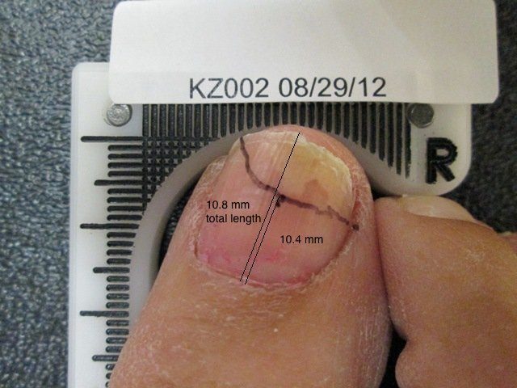
In this retrospective study, GIMP 2.8 will be used to measure the mm of clear nail of the onychomycosis infected great toenail in the digital image, defined as the distance from the proximal nail fold to the most proximal area of nail dystrophy. A straight line will be created between the two points, and the GIMP 2.8 system software will formulate a measurement of that line. An example is shown in Figure 1 to the right, demonstrating how total nail length and linear measurement of mm of clear nail from the proximal nail fold to the most proximal area of nail dystrophy is determined.
Figure 1: Application of the GIMP 2.8
to measurement of mm clear nail length

MEASUREMENT METHODOLOGY
The study investigator will evaluate and measure mm of clear nail for each of the 100 presented unmarked non-labeled coded photographic images in the randomized order of presentation as described in the STUDY DESIGN section above, and following the instructions for operation and application of the GIMP 2.8 software system for measurement of linear mm clear nail measured from the proximal nail fold to the most proximal dystrophic component, as detailed in the ‘GIMP 2.8 Software Measurement Methodology Instruction Sheet’ (Appendix D).

The investigator is further instructed as follows:

- For each photograph, use the reference mm scale in the digital image to determine and record the mm of clear nail for that great toenail as the distance from the toenail notch to the distal edge of the lunula.

- If the proximal visualized edge of fungal involvement is below the notch (evidence of further ingrowth of the fungal infection that extends below the notch), please use this lowest point as the reference to measure mm of clear nail to the distal edge of the lunula instead of the notch.

- Following the instructions for operation and application of the GIMP 2.8 software system for measurement of linear mm clear nail measured from the proximal nail fold to the most proximal dystrophic component, as detailed in the ‘GIMP 2.8 Software Measurement Methodology Instruction Sheet’ (Appendix D), calculate the mm of clear nail.

- Record the calculated mm of clear nail for the respective digital image in the box to the right of the corresponding coded ID for the digital image on the ‘Evaluator Photograph Measurement Record Form’.

STATISTICAL ANALYSIS PLAN

The aim of this retrospective study is to determine if there is a treatment effect of application of the Erchonia LunulaLaser™ for individuals with onychomycosis of the toenail.

PRIMARY EFFICACY OUTCOME MEASURE: The primary efficacy outcome measure in this study is the mm of clear nail growth at 6 months post-procedure administration end relative to Baseline (pre-procedure administration) for onychomycosis-infected great toenails, with ‘mm of clear nail’ defined as the linear measurement of mm of clear nail from the proximal nail fold to the most proximal area of nail dystrophy, measured using the validated GNU Image Manipulation Program (GIMP 2.8) software system and associated methodology.

Individual Great Toenail Success
Individual great toenail success is defined as a minimum demonstration of 3mm of clear nail growth at 6 months post-procedure administration end relative to Baseline (pre-procedure administration).

This individual great toenail success criteria was stipulated by the FDA in prior pre-IDE protocol and submission reviews, as follows: “If you revise your IFU to ‘increase in clear nail in patients with onychomycosis’ please note that devices cleared for this indication must demonstrate 3mm of clear nail at 6 months.”

Overall Study Success Criteria
Overall study success criteria is defined as a minimum of 60% of evaluated great toenails meeting the individual success criteria.

STATISTICAL METHODS

- Calculation of the proportion of great toenails that demonstrate individual great toenail study success will be performed.
- T-test analysis will be performed to evaluate the mean change in mm clear nail of the great toenails from baseline to 6 months evaluation.

APPENDIX A

ESTABLISHMENT OF
NON-SIGNIFICANT RISK

ERCHONIA CORPORATION: NONSIGNIFICANT RISK DETERMINATION
FOR THE ERCHONIA LUNULALASER™ DEVICE

DEVICE NAME: Erchonia LunulaLaser™

INVESTIGATIONAL INDICATION: The Erchonia LunulaLaser™ is being used for the investigational indication of treatment for onychomycosis of the toenail, with the following intended indication for use statement: “The Erchonia LunulaLaser™ device is indicated for use for the temporary increase of clear nail in patients with onychomycosis (e.g., dermatophytes Trichophyton rubrum and T. mentagrophytes, and/or yeasts Candida albicans, etc.).”
DEVICE DESCRIPTION & SPECIFICATIONS: The Erchonia LunulaLaser™ is a dual-diode laser of 635 nm and 405 nm wavelength. The light emitting diodes are manufactured by DLC and classified by the Center for Devices and Radiological Health (CDRH) as Class II laser diodes. The LunulaLaser™ is a portable floor device with an AC power adapter.

The LunulaLaser™ has the following specifications:

Power | 16.0-18.5mW for the 635nm diode  21.5-24.0mW for the 405nm diode
Wavelength | 635nm & 405nm
Waveform | Constant Wave (CW)
Energy Source | Dual diode collected then line dispersed (coherent)
Power Supply | 100-240 VAC 50/60 Hz
Energy Delivery | Portable floor device
Treatment Time | 12 minutes

The Erchonia LunulaLaser™ is shown in Figure 1 below:
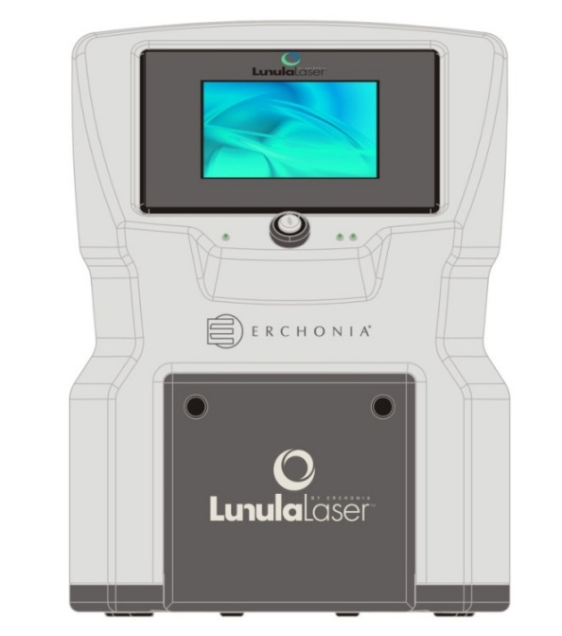
Figure 1: The Erchonia LunulaLaser™

DEVICE SYSTEM COMPONENTS: The individual system components of the Erchonia LunulaLaser™ are displayed in Figures 2, 3 and 4 below and labeled and described in the associated text.

Figure 2: System components 1 through 6 of the Erchonia LunulaLaser™

- Power Indicator Light
- Pull Knobs / Stops
- Door / Foot Platform
- Touch Screen
- Key Switch
- Diode Light Indicator

1. Power Light Indicator: When the LunulaLaser™ is ON, the power light indicator shows GREEN. When the device is OFF, the LED is NOT lit.

2. Pull Knobs / Stops: On both sides of the door, there are protrusions that function as pull knobs when the door is closed. Pulling on these opens the door. Once the door is open, the protrusions function as stops, supporting the weight of the patient’s foot.

3. Door / Foot Platform: In the closed position (as shown on figure 2 above), this element is a door. The door / foot platform is multifunctional: when open, the inside of the door becomes the back half of the treatment platform.

4. Touch Screen: The touch screen functions as a display screen and an input panel, providing information to the user and a means to operate the device by touching the appropriate icon.

5. Key Switch: The key switch is the ON/OFF mechanism, shown as “O” = OFF and “I” = ON. When ‘ON,’ the power light indicator (item #1) will be lit.

6. Diode Light Indicator: When the device is ON and in treatment, these lights are lit, showing that each diode is emitting device light.

Figure 3: System components 7 and 8 of the Erchonia LunulaLaser™

- Laser Output Heads
- Magnetic Latch

7. Laser Output Heads: Each one of the two output heads emits laser light: one light is a 405nm violet beam and the other light is a 635nm red beam.

8. Magnetic Latch: The Door / Front Platform is held in the closed position by this magnetic latch.

Figure 4: System components 9 through 12 of the Erchonia LunulaLaser™

9. Handle
10. Compliance Label
- Serial Number
- Power Inlet / Fuse Holder

9. Handle: The handle enables the user to pick up, carry and / or move the device with ease.

10. Compliance Label: Contains all the governing agencies required information regarding the device, including but not limited to the US FDA device classification, EU classification, output information and power inlet symbols. Also includes the manufacturer name and address (shown in Figure 5 below).).
Figure 5: Compliance Label

11. Serial Number: This is the unique identifier for the device. All information regarding this device is associated with the serial number.

12. Power Inlet Module / Fuse Holder: The device contains a flexible detachable power cord. TNOTE: Make sure the power cord is plugged into the device at this location prior to plugging it into a wall socket. The power cord does not contain any operator-serviceable components. The power inlet module also contains a fuse holder. Replacing the fuses is the only service that can be conducted by the end-user. Fuses to be rated a T2AL 250V with an input to cover 100 – 240V~ 1.5-.5A, 50-60 Hz.

DETERMINATION OF DEVICE SAFETY

PROTECTIVE EYEWEAR: The Erchonia LunulaLaser™ is classified by the FDA/IEC as a Class 2 laser device. This designation represents a current standard for use in order to ensure the safety of the patient. A Class 2 laser is determined to have a chronic viewing hazard. Pointing the laser beam directly into the eye and maintaining it there for an extended period of time could prove to be damaging.

To ensure there is no possible instance of residual effect, a pair of specialty glasses (shown in Figure 6 below) is provided for use during in-office procedure applications with the Erchonia LunulaLaser™ laser device. These safety glasses are Kentek Corporation Filter #6101 light blue glasses with approximate VLT 63% that sufficiently and effectively block the laser light spectrum of the LunulaLaser™ laser device as follows: 405nm (OD 1.22) & 635nm (OD 2.07).

Figure 6: Kentek Corporation Filter #6101 Safety Glasses

FOOD AND DRUG ADMINISTRATION (FDA) DETERMINATION OF NON-SIGNIFICANT RISK (NSR) STATUS

- REGULATORY CLEARANCES: The Food and Drug Administration (FDA) has determined the family of Erchonia® low level laser devices to be non-significant risk (NSR) through numerous 510(k) clearances, as follows.

1. 510(k)#: K132940
Device Name: Erchonia® Allay™
Indications for Use: The Erchonia® Allay™ is indicated as an adjunct to reducing chronic heel pain arising from plantar fasciitis.

2. 510(k)#: K121695
Device Name: Erchonia® Zerona
Indications for Use: The Erchonia Zerona is indicated for use as a non-invasive dermatological aesthetic treatment as an adjunct for individuals intending to undergo liposuction procedures for the reduction of circumference of hips, waist, and thighs.

3. 510(k)#: K121690
Device Name: Erchonia® Zerona-AD
Indications for Use: The Erchonia Zerona-AD is indicated for use as a non-invasive dermatological aesthetic treatment as an adjunct for individuals intending to undergo liposuction procedures for the reduction of circumference of the upper arms.

4. 510(k)#: K120257
Device Name: Erchonia® MLS, Zerona
Indications for Use: The Erchonia® MLS, Zerona is indicated for non-invasive dermatological aesthetic treatment for the reduction of the circumference of the upper arms.

5. 510(k)#: K101430
Device Name: MLS-AC Derma ScannerTM
Indications for Use: The MLS-AC Derma ScannerTM is indicated while using the red diodes for adjunctive use in providing temporary relief of minor chronic neck and shoulder pain of musculoskeletal origin, and while using the blue diode, to treat moderate inflammatory Acne Vulgaris.

6. 510(k)#: K082609
Device Name: Erchonia® ML Scanner (MLS)
Indications for Use: The Erchonia® ML Scanner is indicated for use as a non-invasive dermatological aesthetic treatment for the reduction of circumference of hips, waist and thighs.

7. 510(k)#: K072206
Device Name: Erchonia® EML Laser
Indications for Use: For the temporary reduction in post-surgery pain at 24 hours after surgery following bilateral breast augmentation surgery.

8. 510(k)#: K062792
Device Name: Erchonia IOTO_240
Indications for Use: The Erchonia IOTO_240 is a galvanic generator that is indicated for use in tap water iontophoresis to treat palmer hyperhidrosis and plantar hyperhidrosis.

9. 510(k)#: K050672
Device Name: Erchonia® EVRL Laser
Indications for Use: The Erchonia EVRL Laser is generally indicated:

  - while using the red diode, for adjunctive use in providing temporary relief of minor chronic neck and shoulder pain of musculoskeletal origin, and
  - while using the blue diode, to treat dermatological conditions, and specifically
indicated to treat moderate inflammatory Acne Vulgaris.

10. 510(k)#: K041139
Device Name: Erchonia® EML Laser
Indications for Use: The Erchonia EML is indicated as an adjunct to liposuction procedures of the thighs, hips and stomach for reduction of pain associated with the recovery process.

11. 510(k)#: K100509
Device Name: Erchonia® THL1 Laser
Indications for Use: The THL1 Laser is indicated for use in providing temporary relief of minor chronic neck and shoulder pain of musculoskeletal origin.
- PRE-IDE REVIEWS: FDA has reviewed several clinical study protocols employing the Erchonia LunulaLaser™ device (also previously called the Erchonia EML and the Erchonia FX-405™) through the following pre-IDE reviews, including the currently presented clinical study protocol, with the concurrence from FDA that the clinical study protocols and application of the Erchonia LunulaLaser™ therein is considered non-significant risk (NSR), as follows:

- Pre-IDE#I090848 review: A double-blind, placebo-controlled randomized evaluation of the effect of the Erchonia® EML on treating toenail onychomycosis; Version 1.0; November 4, 2009.

- Pre-IDE#I090848 Supplement review: A double-blind, placebo-controlled randomized evaluation of the effect of the Erchonia® FX-405™ on treating toenail onychomycosis; Version 1.1; November 25, 2009.

- Pre-IDE#I120687 review (current protocol): An Evaluation of the Effect of the Erchonia LunulaLaser™ on the Temporary Increase of Clear Nail in Patients with Toenail Onychomycosis; Version 6.0, August 7, 2012; Erchonia Corporation; with modifications incorporating the outcome of the review made to create the current protocol version of Version 7.0; December 27, 2012.

INSTITUTIONAL REVIEW BOARD (IRB) DETERMINATION OF NON-SIGNIFICANT RISK (NSR) STATUS

Erchonia® Corporation low level laser devices have been determined to be non-significant risk (NSR) when applied in various clinical studies through several IRBs, as follows

- Western Institutional Review Board (WIRB®) has previously determined the Erchonia LunulaLaser™ device (also previously called the Erchonia EML and the Erchonia FX-405™) as non-significant risk (NSR)when applied in the following clinical studies also evaluating the indication of treating toenail onychomycosis:

- WIRB PRO NUM: 20130029: Erchonia® LUNULA™: An Evaluation of the Effect of the Erchonia LUNULA™ on the Temporary Increase of Clear Nail in Patients with Toenail Onychomycosis Clinical Study Protocol 2

- WIRB PRO NUM: 20121330: Erchonia LUNULA™: An Evaluation of the Effect of the Erchonia LUNULA™ on Treating Toenail Onychomycosis Clinical Study Protocol; Version 6.0 August 7, 2012

- WIRB PRO NUM: 20110461: Erchonia FX-405™: An Evaluation of the Effect of the Erchonia FX-405™ on Treating Toenail Onychomycosis Clinical Study Protocol; Version 3.0 March 19, 2011

- Western Institutional Review Board (WIRB®) has also previously determined Erchonia low level laser devices as non-significant risk (NSR) when applied in the following clinical studies:

- WIRB PRO NUM: 20141594: Erchonia® Verju™ + Suprenza™: An evaluation of the effect of the Erchonia® Verju™ Laser with Suprenza™ to reduce central adiposity in overweight and obese individuals

- WIRB PRO NUM: 20140535: Erchonia® EML: A randomized evaluation of the effect of the Erchonia® EML laser on the autologous transfer of fat to the hands from fat harvested during laser-assisted liposuction of the thighs and/or hips and/or stomach pilot study protocol

- WIRB PRO NUM: 20131165: Erchonia® EZ6: An evaluation of the effect of the
Erchonia® Zerona 6 Headed Scanner (EZ6) six-week treatment protocol on circumference reduction of the waist, hips, thighs and upper abdomen clinical study protocol

- WIRB PRO NUM: 20130851: Erchonia® MLS: An evaluation of the effect of the Erchonia® ML Scanner (MLS) laser on increasing blood circulation in individuals with chronic heel pain clinical study protocol

- WIRB PRO NUM: 20130488: Erchonia® TMJ Laser: A pilot evaluation of the effect of the Erchonia® TMJ Laser on reducing jaw pain and improving jaw function for individuals with Temporomandibular Joint (TMJ) Disorder

- WIRB PRO NUM: 20130343: Erchonia® Obesity Laser: A double-blind, placebo-controlled, randomized evaluation of the effect of the Erchonia® Obesity Laser on the reduction of the circumference of the hips, waist and upper abdomen for individuals with Body Mass Index (BMI) of 30 to 40 kg/m²

- WIRB PRO NUM: 20121548: Erchonia® MLS: A double-blind, placebo-controlled randomized evaluation of the effect of the Erchonia® ML Scanner (MLS) laser on reducing pain associated with degenerative arthritis (osteoarthritis) of the midfoot clinical study protocol

- WIRB PRO NUM: 20120911: Erchonia® MLS: A double-blind, placebo-controlled randomized evaluation of the effect of the Erchonia® ML Scanner (MLS) on body contouring of the waist, hips and thighs five-day treatment protocol clinical study protocol

- WIRB PRO NUM: 20120787: Erchonia® MLS: A double-blind, placebo-controlled randomized evaluation of the effect of the Erchonia® ML Scanner (MLS) on low back pain clinical study protocol

- WIRB PRO NUM: 20120489: Erchonia® MLS: A double-blind, placebo-controlled randomized evaluation of the effect of the Erchonia® ML Scanner (MLS) on lipid panel levels clinical study protocol

- WIRB PRO NUM: 20111793: Erchonia® MLS: A double-blind, placebo-controlled randomized evaluation of the effect of the Erchonia® ML Scanner (MLS) laser on chronic heel pain clinical study protocol

- WIRB PRO NUM: 20110758: Erchonia® MLS: A pilot evaluation of the effect of the Erchonia® ML Scanner (MLS) laser device on enhancing body weight loss, fat loss and circumference reduction of the waist, hips and thighs clinical study protocol

- WIRB PRO NUM: 20110331: Erchonia® MLS: An evaluation of the effectiveness of the Erchonia® ML Scanner (MLS) as a non-invasive dermatological aesthetic treatment for the reduction of circumference of the upper arms clinical study protocol
- Independent Review Consulting, Inc.’s/Ethical and Independent Review Services has previously determined Erchonia low level laser devices as non-significant risk (NSR) when applied in the following clinical studies:

- IRC# 07150, NSR# DER-006: Erchonia® MLS: A double blind, placebo-controlled randomied evaluation of the effect of the Erchonia® ML Scanner (MLS) on body contouring of the waist, hips and thighs clinical study protocol.

- IRC# 09120, NSR# DER-015: Erchonia® MLS: A double-blind, placebo-controlled randomized evaluation of the effect of the Erchonia® ML Scanner (MLS) on reducing the appearance of cellulite clinical study protocol.

- IRC# 08167, NSR# DER-009: Erchonia® MLS: A double blind, placebo-controlled randomized evaluation of the effect of the Erchonia® ML Scanner (MLS) on capsular contracture clinical study protocol.

- IRC# 09059, NSR# DER-010: Erchonia® MLS: A double blind, placebo-controlled randomized evaluation of the effect of the Erchonia® ML Scanner (MLS) in combination with silicone sheets on cellulite pilot study protocol.

OTHER POTENTIAL RISKS: Other potential risks and their mitigation include:

- Electric shock: operator risk only: mitigated through electrical safety testing.
- Electromagnetic interference: mitigated through EMC/EMI testing
- User error: mitigated through instructions for use documentation.

LABELING: The device used in this clinical study shall be labeled with the following statement:

“CAUTION – Investigational device. Limited by United States law to Investigational use.”
Once cleared for market in the U.S., the Erchonia LunulaLaser™ device will be labeled as prescription devices, per 21 CFR § 801.109.

NON-SIGNIFICANT RISK STATEMENTS

- Do you contend that this device as used in this protocol is an NSR device?
__ Yes ___No
- Has another IRB decided this device is SR?
___ Yes __ No
- Does this type of device appear as SR on the FDA Information Sheet?
___ Yes __ No

APPENDIX B

GIMP 2.8 SOFTWARE VALIDATION STUDY PROTOCOL

A Validation Protocol for Application of the
GNU Image Manipulation Program (GIMP 2.8)
to the Measurement of
mm of Clear Nail on Toenails

ERCHONIA CORPORATION

Version 2.0
April 24, 2015

TABLE OF CONTENTS

STUDY INFORMATION 1
SPONSOR 1
CLINICAL CONSULTANT 1
STUDY INVESTIGATOR 1
STUDY EVALUATORS 1
PURPOSE OF STUDY 1
FDA RESOURCES UTILIZED 1
BACKGROUND AND STUDY OBJECTIVE 2
BACKGROUND 2
STUDY OBJECTIVE 3
STUDY DESIGN 4
MATERIALS 4
SAMPLE 5
STUDY INVESTIGATOR 6
STUDY EVALUATORS 6
BLINDING AND RANDOMIZATION 7
PRIVACY AND CONFIDENTIALITY 7
STUDY PROCEDURE 8
STUDY INVESTIGATOR ACTIVITIES 8
STUDY PHOTOGRAPH SET SELECTION 8
PROCEDURAL TRAINING AND EVALUATION OF STUDY EVALUATORS 9
STUDY EVALUATOR ACTIVITIES 10
STUDY PHOTOGRAPHIC SET EVALUATION 10
STATISTICAL ANALYSIS PLAN 11

APPENDICES
APPENDIX A: INFORMED CONSENT FORM
APPENDIX B: MANUAL MEASUREMENT METHODOLOGY INSTRUCTION SHEET
APPENDIX C: GIMP 2.8 MEASUREMENT METHODOLOGY INSTRUCTION SHEET
APPENDIX D: RANDOMIZATION SCHEDULES

STUDY INFORMATION

SPONSOR
Erchonia Corporation
2021 Commerce Drive
McKinney, TX 75069
Contact: Mr. Steven Shanks, President
Telephone: 214-544-2227
e-mail: sshanks@erchonia.com

CLINICAL CONSULTANT
Regulatory Insight, Inc., Nashville Office
1503 Red Oak Drive
Brentwood TN 37027
Contact: Elvira Walls, Clinical Consultant
Telephone: 615-712-9743
e-mail: elvira@reginsight.com

STUDY INVESTIGATOR
Kerry Zang, DPM
Arizona Institute of Footcare Physicians
1620 S. Stapley Dr., Suite 132
Mesa, AZ 85204
Telephone: 480-834-8804
e-mail: kerryzang@aol.com

STUDY EVALUATORS

1. Shah Askari, DPM

2. Sue Erredge, DPM

3. Mia Horvath, DPM

TEST SITE
St. Luke’s Hospital
1800 E Van Buren Street
Phoenix, Arizona 85006
Telephone: 602-251-8100

FDA RESOURCES UTILIZED
This validation study protocol was evaluated by the FDA through the Q-Submission review process under Q150259. The Q-submission was received by the FDA on 2/23/15 and the study Sponsor, Erchonia Corporation, received FDA’s written responses to questions asked and additional pertinent review information on 4/2/15. FDA’s recommendations for protocol modification and clarity were subsequently incorporated into this validation study protocol prior to executing the study. Q150259 was reviewed under the leadership of:

- LT Atiq Chowdhury, M.S., Biomedical Engineer &Lead Reviewer
General Surgery Devices Branch I (GSDB1)
Division of Surgical Devices (DSD); Office of Device Evaluation (ODE)
Center for Devices and Radiological Health (CDRH)
Food and Drug Administration; U.S. Public Health Service
Telephone: 301-796-6391
e-mail: atiq.chowdhury@fda.hhs.gov
BACKGROUND AND STUDY OBJECTIVE

BACKGROUND

The GNU Image Manipulation Program (GIMP 2.8) was originally released in January 1996 as the General Image Manipulation Program, having been created by Spencer Kimball and Peter Mattis as the result of a college project at the University of California, Berkeley. In 1997, the definition of the acronym ‘GIMP’ was changed to mean the GNU Image Manipulation Program, by permission of Richard Stallman, to also reflect its existence under the GNU Project.

The GNU Image Manipulation Program (GIMP 2.8) is a multi-platform image/photo manipulation software. It is a raster editor, such that it performs operations directly on the pixels that make up the image and not a vector editor.

GIMP is suitable for a variety of image manipulation and analysis tasks, including photo retouching, image composition, and image construction. It has many capabilities. It can be used as a simple paint program, an expert quality photo retouching program, an online batch processing system, a mass production image renderer, an image format converter, etc. It is designed to be augmented with plug-ins and extensions to do just about anything. The advanced scripting interface allows everything from the simplest task to the most complex image-manipulation procedures to be easily scripted.

Complete details of GIMP, its specifications, operations and applications can be found on the website: www.gimp.org.

Clinical Research

Applicable research abstracts and references are provided below.

Measuring the Pain Area: An Intra- and Inter-Rater Reliability Study Using Image Analysis Software.
Dos Reis FJ, de Barros E Silva V, de Lucena RN, Mendes Cardoso BA, Nogueira LC.
Pain Pract. 2014 Dec 10.

Pain drawings have frequently been used for clinical information and research. The aim of this study was to investigate intra- and inter-rater reliability of area measurements performed on pain drawings. Our secondary objective was to verify the reliability when using computers with different screen sizes, both with and without mouse hardware. Pain drawings were completed by patients with chronic neck pain or neck-shoulder-arm pain. Four independent examiners participated in the study. Examiners A and B used the same computer with a 16-inch screen and wired mouse hardware. Examiner C used a notebook with a 16-inch screen and no mouse hardware, and Examiner D used a computer with an 11.6-inch screen and a wireless mouse. Image measurements were obtained using GIMP and NIH ImageJ computer programs. The length of all the images was measured using GIMP software to a set scale in ImageJ. Thus, each marked area was encircled and the total surface area (cm²) was calculated for each pain drawing measurement. A total of 117 areas were identified and 52 pain drawings were analyzed. The intra-rater reliability between all examiners was high (ICC = 0.989). The inter-rater reliability was also high. No significant differences were observed when using different screen sizes or when using or not using the mouse hardware. This suggests that the precision of these measurements is acceptable for the use of this method as a measurement tool in clinical practice and research. PMID: 25490926

Novel software-based and validated evaluation method for objective quantification of bone regeneration in experimental bone defects.
Schönberger T¹, Kasten P, Fechner K, Südkamp NP, Pearce S, Niemeyer P.
Z Orthop Unfall. 2010 Jan;148(1):19-25.

AIM: The quantification of newly formed bone in experimental defect models is a problem in various experimental set-ups. Several methods have been described to evaluate and quantify the regeneration of newly formed bone in various animal models. Most methods only describe the amount of regenerated tissue on a semi-quantitative level, the results significantly depend on the subjective rating of the observer and such evaluation methods have not been validated in terms of objectivity and reliability. The aim of the present study was to introduce a novel evaluation method for the accurate quantification of bone regeneration on digital X-ray images using a freely available digital image software analysis program (GIMP).

METHODS: The method introduced here contains 5 steps: standardization of size and color, determination of range of interest (ROI), defining different qualities of mineralization, pixel analysis with histogram function, similar to the Hondsfield index, and quantification. In order to evaluate the objectivity and reliability, the quantification method was compared to semi-quantitative scores described by Mosheiff and Werntz for inter- and intraobserver variability. Six observers were asked to determine bone regeneration in 16 X-ray images of 2 different animal models. In order to describe intraobserver variability, the evaluation was repeated after a period of 4 weeks. Statistical analysis including determination of intra- and interobserver variability (Bland-Altman coefficient of reproduction) was performed using SAS software.

RESULTS: For both experimental set-ups analyzed in this project (rabbit and sheep bone defects), the objectivity was significantly higher in the GIMP-based evaluation compared to the evaluation according to Mosheiff and Werntz using the Bland-Altman coefficient (rabbit: GIMP: 0.095, Mosheiff: 0.272, Werntz: 0.283; sheep: GIMP: 0.098, Mosheiff: 0.658, Werntz: 0.668). Analogous results were obtained for reliability (rabbit: GIMP: 0.086, Mosheiff: 0.221, Werntz: 0.385; sheep: GIMP: 0.102, Mosheiff: 0.339, Werntz: 0.623).

CONCLUSION: This quantification method introduced here has proved to be a reliable and "easy-to-use" tool in order to perform objective quantification of bone regeneration in 2 different experimental set-ups. It offers a more detailed and quantitative way for precise determination of regenerated tissue and is characterized by higher objectivity and reliability compared to other semi-quantitative evaluation methods. The objectivity seems to be independent of the animal model to which the method is applied.
PMID: 20135589

CURRENT STUDY OBJECTIVE
The objective of this study is to validate the GNU Image Manipulation Program (GIMP 2.8) for the measurement of mm of clear nail from the proximal nail fold to the most proximal area of nail dystrophy from digital photographs of onychomycosis infected great toenails for the purpose of results analysis of clinical trial data evaluating the treatment effect of low level laser therapy on toenail onychomycosis, whose results are intended to support a 510(k) submission for the indication off treatment of onychomycosis.

STUDY DESIGN

MATERIALS
The following assessment materials will be used in this validation study.

- High-resolution photographic documentation of the great toenail: Digital photographic documentation of the great toenail will be taken using a high resolution digital camera, following a standardized methodology, ensuring consistency of equipment, lighting, distance, resolution, etc. for all toes.

The photograph will be taken with the great toe placed in the horizontal-vertical mm scale measurement recording device shown in Figure 1 below.

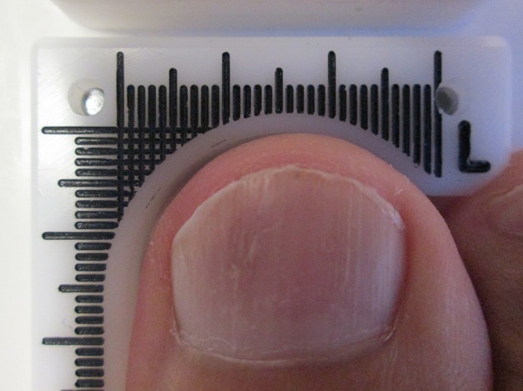

Figure 1: Application of the mm scale recording device

- Manual Ruler: A manual mm marked straight-line ruler will be used to measure the distance of the straight line formed between the point of proximal nail fold to the point of most proximal portion of dystrophy on the great toenail in each digital photograph in the mm scale recording device shown and described above.

- The GNU Image Manipulation Program (GIMP 2.8): GIMP 2.8 will be used to measure the mm of clear nail of the onychomycosis infected great toenail in the digital image, defined as the distance from the proximal nail fold to the most proximal area of nail dystrophy. A straight line will be created between the two points, and the GIMP 2.8 system software will formulate a measurement of that line. As example is shown in Figure 2 below of how total nail length and linear measurement of mm of clear nail from the proximal nail fold to the most proximal area of nail dystrophy.

Figure 2: Application of the GIMP 2.8
to measurement of mm clear nail length

SAMPLE
The sample in this validation study will comprise photographs of great toenails with varying degrees of onychomycosis disease involvement selected from amongst an existing pool of photographs taken during prior research studies and for which the subjects have provided prior consent to permit the photographs to be used for research purposes. The selected photographs will form an independent photo set, such that no photo in the validation study photo set will be taken from the photo set to be later assessed for submission purposes.

Sample Size
Twenty (20) great toenails will be selected for this validation study, as follows:

- 5 great toenails with 0% to 25% onychomycosis involvement
- 5 great toenails with 26% to 50% onychomycosis involvement
- 5 great toenails with 51% to 75% onychomycosis involvement
- 5 great toenails with 76% to 100% onychomycosis involvement

Each of the 5 photographs of great toenails in each of the 4 onychomycosis involvement categories above will be selected to cover the full range of disease severity within the respective category.

Rationale for Sample Size
Sample size has been determined based on the following parameters established for the purposes of validation of the application of the GIMP 2.8 software methodology to the measurement of mm of clear nail in digital images of onychomycosis involved great toenails:

- The precision of a manual mm ruler, defined as the smallest fractional or decimal division on the scale of the instrument (the smallest unit it can measure), is 1 mm.
- Tolerance is the greatest range of variation that is acceptable and is determined from the precision value of the measurement tool as 1 mm.
- Therefore, the maximal tolerance difference in measurement using a manual mm ruler - that corresponds to the acceptable margin of error in measurement - is determined as 1 mm.
- The maximal tolerated difference is determined by adding and subtracting one-half of the precision of the measuring instrument to the measurement, i.e. 0.5 mm.
- For example, if the mm clear nail measurement made for great toenail digital image ‘A’ is recorded by study evaluator #1 as 7 mm using the manual mm ruler methodology, then, given that the ruler has a precision of 1 mm, then the tolerance interval in the measurement is 7 ± 0.5 mm - from 6.5 mm to 7.5 mm. As such, the corresponding measurement using the GIMP 2.8 software methodology must be within this range of values in order for the 2 measurements to be considered the same.

Considering a maximal tolerated difference of 1 mm between the manual ruler and GIMP 2.8 software measurements of the same digital image, with a common standard deviation of 0.5 mm, intended application of a two-tailed test with an alpha value of 0.05 and Power of 0.8, the sample size of 4 subjects per group (0-25%, 26-50%, 51%-75% and 76-100% onychomycosis involvement, separately) has been determined using the following reference calculator: Hypothesis Testing: Categorical Data - Estimation of Sample Size and Power for Comparing Two Binomial Proportions in Bernard Rosner's Fundamentals of Biostatistics.

This sample size has been increased to 5 great toenail images per each of the 4 onychomycosis categories to ensure comprehensive representation of the full range of onychomycosis involvement levels within each category.
STUDY INVESTIGATOR
The Study Investigator will be responsible for oversight of this validation study, including selection of the study photo set, and the procedural training and training success evaluation of the three independent Study Evaluators.

STUDY EVALUATORS
There will be three independent Study Evaluators in this validation study. Each of the three independent Study Evaluators will evaluate the entire photographic set twice: one time in the role of ‘GIMP Evaluator’ and one time in the role of ‘Manual Device Evaluator’, as follows:

- GIMP Evaluator: In the role of ‘GIMP Evaluator’ each of the three independent Study Evaluators will, independently, apply the GIMP 2.8 program methodology to the set of 20 unmarked digital photographs of onychomycosis involved great toenails to record linear measurement of mm of clear nail from the proximal nail fold to the most proximal area of nail dystrophy.

- Manual Device Evaluator: In the role of ‘Manual Device Evaluator’, each of the three independent Study Evaluators will, independently, record linear measurement of mm of clear nail from the proximal nail fold to the most proximal area of nail dystrophy from the set of 20 unmarked digital photographs of onychomycosis involved great toenails using the manual mm marked straight-line ruler methodology.

Study Investigator and Study Evaluators Qualifications for Study Participation
The Study investigator and each of the three Study Evaluators will be Board Certified Podiatrists (DPMs) with current clinical practice licenses who are experienced in the diagnosis, assessment and treatment of toenail onychomycosis. Therefore all 4 investigative parties possess the credentials, skills and experience to identify the margin of nail dystrophy in onychomycosis involved toenails.

None of the Study Investigator nor any of the three Study Evaluators will be employees or family members of the PI, Erchonia Corporation or Regulatory Insight.

BLINDING AND RANDOMIZATION
Photographs will be coded according to the letters ‘A’ through ‘T’ with no identifying information provided.

The photographic set randomization process will be as follows:

- The set of 20 subject great toenail study photographs will be coded in non-identifying, randomized order from ‘A’ to ‘T’, with the ‘A’ to ‘T’ ordering of the photographs randomized 6 different times, such that there will be 6 sets of the 20 photographs, each presenting the photographs in a different randomized order.
- Each of the three independent Study Evaluators will be randomly assigned 2 of the randomized photographic sets
- Each of the three independent Study Evaluators will evaluate one of the randomized photographic sets they are assigned using the GIMP 2.8 software methodology, and the other randomized photographic set they are assigned using the manual ruler measurement method.
- The order of evaluation – GIMP software and manual ruler measurement methodologies – will also be randomized between the three independent Study Evaluators.

Randomization will be attained using computer generation sequence methodology, using the online generator www.randomization.com. Each computer generated randomization sequence is unique and will therefore not be able to be replicated.

PRIVACY AND CONFIDENTIALITY
Subject privacy and confidentiality will be maintained in this validation study through assignment of lettering ‘A’ through ‘T’ on the photographs, with no additional identifying information. The photograph set will not include the subject’s face or any other visually identifiable physical feature of the subject, nor will the photographs be labeled with the subject’s name or any other identifying information that could potentially connect any photograph to any particular subject in this validation study.

STUDY PROCEDURE

STUDY INVESTIGATOR ACTIVITIES

STUDY PHOTOGRAPH SET SELECTION

Determination of the study photograph set collection will be made by the Study Investigator, a suitably qualified trained and Board certified podiatrist experienced in making determination of disease status and quantification of severity of disease involvement.

Selection of suitable great toenails for the validation study from the full set of available photographs will be made according to the qualification criteria used for great toenail selection in the original clinical study whose photographs will be subsequently re-analyzed using the GIMP 2.8 software assuming successful outcome of this validation study.

This criteria is presented below:

Inclusion Criteria
- Great toenail presents with clearly visually identifiable and photographically documentable onychomycosis of the great toenail, or no visible onychomycosis (1 great toenail)
- Onychomycosis has been identified as due to bacterial/fungal infection classified by the investigator as onychomycosis, with the nail presenting positive on visual inspection for somewhat thickened nail plate with a cloudy appearance and some discoloration (white to yellow to brown)
- Onychomycosis etiology has been confirmed through positive fungal KOH testing results

Exclusion Criteria
- The category of the presenting visible great toenail onychomycosis (0%-25% onychomycosis involvement; 26%-50% onychomycosis involvement; 51%-75% onychomycosis involvement; 76%-100% onychomycosis involvement) has already met the quota of 5 qualified enrolled great toenails
- Spikes of disease extending to nail matrix in the great toenail
- Infection involving lunula of the great toenail, e.g. genetic nail disorders, primentary disorders
- Great toenail has less than 2mm clear (unaffected) nail plate length beyond the proximal fold
- Dermatophytoma or “yellow spike/streak” (defined as thick masses of fungal hyphae and necrotic keratin between the nail plate and nail bed) on the great toenail
- Onychogryphosis
- Proximal subungual onychomycosis
- White superficial onychomycosis

The evaluator will select qualified great toenails for this validation study until 5 great toenails have been selected to represent the range of disease involvement in each of the 4 onychomycosis involvement categories (0%-25%; 26%-50%, 51%-75% and 76%-100% onychomycosis involvement).

PROCEDURAL TRAINING AND EVALUATION OF STUDY EVALUATORS

Procedural Training of Study Evaluators
After the full set of 20 subject photographs has been taken, the Study Investigator will train the three Study Evaluators on how to apply both the manual measurement methodology and the GIMP 2.8 measurement methodology to perform the linear measurement of mm of clear nail from the proximal nail fold to the most proximal area of nail dystrophy on digital photographs of a great toenail placed in the mm measurement device, as is to be evaluated in the this validation study.

The training procedures are as follows:

- Training on Application of the Manual Measurement Methodology: The Study Investigator:

- provides each of the 3 independent Study Evaluators with a:

- digital photograph of an onychomycosis involved great toenail in the horizontal-vertical mm measurement device
- manual mm marked straight-line ruler
- Manual Measurement Methodology instruction sheet

- reviews the Manual Measurement Methodology instruction sheet with the Study Evaluators and demonstrate each step on the same digital photograph. The Manual Measurement Methodology instruction sheet is contained in Appendix B of this validation protocol document.

- Training on Application of the GIMP 2.8 Measurement Methodology: The Study Investigator will:

- provide each of the 3 independent Study Evaluators with:

- access to a computer with the GIMP 2.8 software program and a pre-loaded digital image of an onychomycosis involved great toenail in the horizontal-vertical mm measurement device
- the GIMP 2.8 Measurement Methodology instruction sheet

- review the GIMP 2.8 Measurement Methodology instruction sheet with the Study Evaluators and demonstrate each step on the same digital photograph. The GIMP 2.8 Measurement Methodology instruction sheet is contained in Appendix C of this validation protocol document.

Procedural Training Evaluation of Study Evaluators

After the three Study Evaluators have been trained by the Study Investigator to both application of the Manual Measurement Methodology and the GIMP 2.8 Measurement Methodology, the Study Investigator will perform an evaluation of the effectiveness of the training and each of the three Study Evaluators’ ability to effectively apply both methodologies as follows:

- Two digital images with different degrees of onychomycosis involvement will be provided to each of the three Study Evaluators. Each Study Evaluator will be required to measure the mm of clear nail for each of the two digital images by applying the Manual Measurement Methodology, and to record the results.

- Two additional digital images, again with different degrees of onychomycosis involvement, will be provided to each of the three Study Evaluators. Each Study Evaluator will be required to measure the mm of clear nail for each of the two digital images by applying the GIMP 2.8 Measurement Methodology, and to record the results.

- The order of presentation of the digital images (within and between each measurement methodology type) will be randomized across Study Evaluators, and each Study Evaluator will perform these evaluations independently of the other such that there will be no possibility of influence or bias between Study Evaluators.

- Once all three Study Evaluators have recorded their measurements for all 4 digital images, the Study Investigator will compare the recordings of each of the three Study Evaluators to those measured by the Study Investigator at an earlier time.

- If a Study Evaluator’s measurements are within 1 mm (the pre-determined cut-off value, as explained in detail below in the STATISTICAL ANALYSIS PLAN SECTION) of that measured by the Study Investigator, training for that Study Evaluator’s will be considered successful.

- If a Study Evaluator’s measurements differ by more than 1 mm of that measured by the Study Investigator, that study evaluator’s training will be considered to have failed, and either the Study Evaluator will be re-trained and re-evaluated, or a new Study Evaluator may be selected, trained and evaluated.

STUDY EVALUATOR ACTIVITIES

STUDY PHOTOGRAPHIC SET EVALUATION
After completion of training and satisfactory evaluation of the Study Evaluators’ ability to accurately apply both the manual and GIMP 2.8 measurement methodologies to measuring the mm of clear nail from a digital image of a great toenail with onychomycosis involvement, each of the three Study Evaluators will evaluate the study photographic set, according to the procedural protocol and methodologies, and according to the randomized order of presentation described in the STUDY DESIGN section above. Each Study Evaluators will perform this process and these functions independently of each other.

STATISTICAL ANALYSIS PLAN

Statistical analysis for validation of the measurement of mm of clear nail from the digital photographs through application of the GIMP 2.8 system will be conducted as follows

PRIMARY OUTCOME EVALUATION
Primary outcome evaluation of successful validation of the application of the GIMP 2.8 measurement methodology to measuring mm of clear nail from digital images of onychomycosis involved great toenails will be through the following means:

- Per Nail Success Criterion: Within Individual Evaluators: The per nail success criterion was pre-defined in relation to an objective cut-off per nail of one (1) mm between the mm of clear nail measurement calculated using the manual mm ruler measurement method and the GIMP 2.8 software measurement method for the same great toenail digital image for each of the three independent Study Evaluators. That is, the maximal tolerated difference between the two measurement techniques that would render the two measurements the same was pre-determined as 1 mm.

The cut-off of 1 mm was selected based on ....

- The precision of a manual mm ruler – the smallest fractional or decimal division on the scale of the instrument (smallest unit it can measure) is 1 mm.
- Tolerance is the greatest range of variation that is acceptable, and can be determined from the precision value, which in the case of a manual ruler measurement has been defined above as 1 mm.
- Therefore, the maximal tolerance difference in measurement using a manual mm ruler - that corresponds to the acceptable margin of error in measurement - is determined as 1 mm.
- The maximal tolerated difference is determined by adding and subtracting one-half of the precision of the measuring instrument to the measurement, i.e. 0.5 mm.
- For example, if the mm clear nail measurement made for great toenail digital image ‘A’ is recorded by study evaluator #1 as 7 mm using the manual mm ruler methodology, then, given that the ruler has a precision on 1 mm, then the tolerance interval in the measurement is 7 ± 0.5 mm - from 6.5 mm to 7.5 mm. As such, the corresponding measurement using the GIMP 2.8 software methodology must be within this range of values in order for the two measurements to be considered the same.

The minimum percent of nails that are required to meet the per-nail success criterion is pre-established as 60%.

- Per Nail Success Criterion: Between/Across Evaluators: Agreement in mm of clear nail measurements amongst two of the three blinded evaluators with respect to the pre-defined minimally acceptable difference will be considered sufficient for accepting the results as supportive of validation of the measurement tool being evaluated.

SECONDARY OUTCOME EVALUATION

The following secondary evaluations will be performed on the data collected:

- Comparison of the median (the middle of the three manual ruler measurements and the middle of the three measurements made using the GIMP 2.8 software method) values will be made as a supportive evaluation of the primary outcome analysis. Median values of two measurements of the same digital photogrpah that differ by no more than the pre-established cut-off of 1 mm (as defined and supported in the PRIMARY OUTCOME EVALUATION section above) will be considered the same.

- Pearson Product-Moment Correlation Co-efficient Analysis will be performed to measure the strength and direction of the linear relationship between the mm of clear nail measurements made using the manual measurement method and the mm of clear nail measurements made using the GIMP 2.8 measurement method for each of the same 20 digital photograph great toenail images within and across all three independent Study Evaluators.

- T-test analysis for two independent samples will be performed to evaluate differences in the mm of clear nail measurement made by each of the three independent Study Evaluators comparing the measurements attained using the manual measurement method versus the GIMP 2.8 measurement method for each Evaluator.

- ANOVA analysis for three indepenedent samples will be performed to evaluate differences in the mm of clear nail measurement made by each of the three Study Evaluators for the same digital image when using the manual measurement method and when using the GIMP 2.8 measurement method.

- Intraclass correlation co-efficient (ICC) analysis will be used to evaluate consistency or reproducibility of the mm of clear nail measurements for the same digital photographic set made between the three independent Study Evaluators.

ICC analysis is applied in this study as a measurement of the strength of the scalar agreement or concordance between the two evaluable variables. An ICC value of ‘0‘ indicates there is no agreement or concordance at all between the two measures, while and ICC value of ‘1‘ indicates perfect agreement or concordance between the two measures. Specifically, the categories of ICC values and the associated indicated agreements are as follows:

ICC Value Range | Agreement
0 - 0.2 | Poor
0.3 – 0.4 | Fair
0.5 – 0.6 | Moderate
- – 0.8 | Strong
> 0.8 | Almost perfect

It is pre-determined for the purposes of analysis of the results of this Validation Study that an ICC value greater than 0.7 will be considered indicative of strong agreement between ratings and positive for demonstrating validation of intra-variation between and within Study Evaluators, respectively.

APPENDIX A

CASE REPORT FORMS

ERCHONIA GIMP 2.8 VALIDATION STUDY
STUDY INVESTIGATOR ACTIVITIES: STUDY PHOTOGRAPH SET SELECTION
Photo # (1-20): | Investigator initials: | Date:

INCLUSION CRITERIA EVALUATION

Mark each box that applies:
Great toenail presents with clearly visually identifiable and photographically documentable onychomycosis of the great toenail, or no visible onychomycosis (1 toenail)
Onychomycosis has been identified as due to bacterial/fungal infection classified by the investigator as onychomycosis, with the nail presenting positive on visual inspection for somewhat thickened nail plate with a cloudy appearance and some discoloration (white to yellow to brown)
Onychomycosis etiology has been confirmed through positive fungal KOH testing results

EXCLUSION CRITERIA EVALUATION

Mark each box that applies:

The category of the presenting visible great toenail onychomycosis (0%-25% onychomycosis involvement; 26%-50% onychomycosis involvement; 51%-75% onychomycosis involvement; 76%-100% onychomycosis involvement) has NOT already met the quota of 5 qualified enrolled great toenails across the spectrum
No spikes of disease extending to nail matrix in the great toenail
No infection involving lunula of the great toenail, e.g. genetic nail disorders, primentary disorders
Great toenail does not have less than 2mm clear (unaffected) nail plate length beyond the proximal fold
No dermatophytoma or “yellow spike/streak” (defined as thick masses of fungal hyphae and necrotic keratin between the nail plate and nail bed) on the great toenail
No onychogryphosis
No proximal subungual onychomycosis
No white superficial onychomycosis

Study Qualification Confirmation:
All boxes for both the Inclusion and Exclusion Criteria Evaluations are marked, and therefore the photograph qualifies for study inclusion
One or more of the boxes for either of the Inclusion and/or Exclusion Criteria Evaluations are not checked; therefore the photograph does not qualify for study inclusion

CATEGORY OF GREAT TOENAIL ONYCHOMYCOSIS INVOLVEMENT

The qualifying toenail in the photograph presents with the following clearly visually identifiable and photographically documentable category of great toenail onychomycosis involvement:

0% to 25% onychomycosis involvement
0% to 5% onychomycosis involvement
6% to 10% onychomycosis involvement
11% to 15% onychomycosis involvement
16% to 20% onychomycosis involvement
21% to 25% onychomycosis involvement
26% to 50% onychomycosis involvement
26% to 30% onychomycosis involvement
31% to 35 onychomycosis involvement
36% to 40% onychomycosis involvement
41% to 45% onychomycosis involvement
46 % to 50% onychomycosis involvement
51% to 75% onychomycosis involvement
51% to 55% onychomycosis involvement
56% to 60 onychomycosis involvement
61% to 65% onychomycosis involvement
66% to 70% onychomycosis involvement
71 % to 75% onychomycosis involvement
76% to 100% onychomycosis involvement
76% to 80% onychomycosis involvement
81% to 85 onychomycosis involvement
86% to 90% onychomycosis involvement
91% to 95% onychomycosis involvement
96 % to 100% onychomycosis involvement

ERCHONIA GIMP 2.8 VALIDATION STUDY
STUDY INVESTIGATOR ENROLLMENT TRACKING SHEET

Mark the category and number for each photograph selected for study inclusion. Only select one photograph per category, and continue until each category and sub-category within has been marked ONE TIME ONLY.

# | 0% to 25% onychomycosis involvement  0% to 5% onychomycosis involvement  6% to 10% onychomycosis involvement  11% to 15% onychomycosis involvement  16% to 20% onychomycosis involvement  21% to 25% onychomycosis involvement
# | 26% to 50% onychomycosis involvement  26% to 30% onychomycosis involvement  31% to 35 onychomycosis involvement  36% to 40% onychomycosis involvement  41% to 45% onychomycosis involvement  46 % to 50% onychomycosis involvement
# | 51% to 75% onychomycosis involvement  51% to 55% onychomycosis involvement  56% to 60 onychomycosis involvement  61% to 65% onychomycosis involvement  66% to 70% onychomycosis involvement  71 % to 75% onychomycosis involvement
# | 76% to 100% onychomycosis involvement  76% to 80% onychomycosis involvement  81% to 85 onychomycosis involvement  86% to 90% onychomycosis involvement  91% to 95% onychomycosis involvement  96 % to 100% onychomycosis involvement

ERCHONIA GIMP 2.8 VALIDATION STUDY
STUDY INVESTIGATOR ACTIVITIES:
PROCEDURAL TRAINING OF STUDY EVALUATORS
Study Investigator initials:

PROCEDURAL TRAINING OF STUDY EVALUATORS

Record below once procedural training to both the Manual Measurement Methodology and the GIMP 2.8 Measurement Methodology has been completed by the Study Investigator for each of the Study Evaluators, as per the respective methodology instruction sheets.

Study Evaluator | Date | Manual Measurement Methodology Training Completed | Date | GIMP 2.8 Measurement Methodology Training Completed
#1
#2
#3

ERCHONIA GIMP 2.8 VALIDATION STUDY
STUDY INVESTIGATOR ACTIVITIES:
PROCEDURAL TRAINING EVALUATION OF STUDY EVALUATOR #1
Study Investigator initials: | Study Evaluator initials:

PROCEDURAL TRAINING EVALUATION OF STUDY EVALUATORS: STUDY EVALUATOR #1

Once procedural training to both the Manual Measurement Methodology and the GIMP 2.8 Measurement Methodology has been completed by the Study Investigator for Study Evaluator #1, present the images AA through DD to Study Evaluator #1 according to the order in the randomization scheduled contained in Appendix B.

Once Study Evaluator #1 records his or her measurements for each of images AA through DD, then enter your prior measurements, calculate the difference between the two measurements, and check the applicable ‘Training Successful’ box.

 | Study Evaluator #1 Measurement (mm) | Study Investigator Measurement (mm) | Difference (mm) | Training Successful (Difference ≤1 mm)
AA |  |  |  | Yes No
BB |  |  |  | Yes No
CC |  |  |  | Yes No
DD |  |  |  | Yes No
Check the applicable box below

All ‘Training Successful’ boxes are marked ‘yes’ | Action
Yes | Proceed with Study Evaluator #1 Activities
No | Select one of the below actions:  Study Evaluator #1 will be re-trained and re-evaluated  Study Evaluator #1 will be replaced

ERCHONIA GIMP 2.8 VALIDATION STUDY
STUDY INVESTIGATOR ACTIVITIES:
PROCEDURAL TRAINING EVALUATION OF STUDY EVALUATOR #2
Study Investigator initials: | Study Evaluator initials:

PROCEDURAL TRAINING EVALUATION OF STUDY EVALUATORS: STUDY EVALUATOR #2

Once procedural training to both the Manual Measurement Methodology and the GIMP 2.8 Measurement Methodology has been completed by the Study Investigator for Study Evaluator #2, present the images AA through DD to Study Evaluator #2 according to the order in the randomization scheduled contained in Appendix B.

Once Study Evaluator #2 records his or her measurements for each of images AA through DD, then enter your prior measurements, calculate the difference between the two measurements, and check the applicable ‘Training Successful’ box.

 | Study Evaluator #2 Measurement (mm) | Study Investigator Measurement (mm) | Difference (mm) | Training Successful (Difference ≤1 mm)
AA |  |  |  | Yes No
BB |  |  |  | Yes No
CC |  |  |  | Yes No
DD |  |  |  | Yes No
Check the applicable box below

All ‘Training Successful’ boxes are marked ‘yes’ | Action
Yes | Proceed with Study Evaluator #2 Activities
No | Select one of the below actions:  Study Evaluator #2 will be re-trained and re-evaluated  Study Evaluator #2 will be replaced

ERCHONIA GIMP 2.8 VALIDATION STUDY
STUDY INVESTIGATOR ACTIVITIES:
PROCEDURAL TRAINING EVALUATION OF STUDY EVALUATOR #3
Study Investigator initials: | Study Evaluator initials:

PROCEDURAL TRAINING EVALUATION OF STUDY EVALUATORS: STUDY EVALUATOR #3

Once procedural training to both the Manual Measurement Methodology and the GIMP 2.8 Measurement Methodology has been completed by the Study Investigator for Study Evaluator #3, present the images AA through DD to Study Evaluator #3 according to the order in the randomization scheduled contained in Appendix B.

Once Study Evaluator #3 records his or her measurements for each of images AA through DD, then enter your prior measurements, calculate the difference between the two measurements, and check the applicable ‘Training Successful’ box.

 | Study Evaluator #3 Measurement (mm) | Study Investigator Measurement (mm) | Difference (mm) | Training Successful (Difference ≤1 mm)
AA |  |  |  | Yes No
BB |  |  |  | Yes No
CC |  |  |  | Yes No
DD |  |  |  | Yes No
Check the applicable box below

All ‘Training Successful’ boxes are marked ‘yes’ | Action
Yes | Proceed with Study Evaluator #1 Activities
No | Select one of the below actions:  Study Evaluator #3 will be re-trained and re-evaluated  Study Evaluator #3 will be replaced

ERCHONIA GIMP 2.8 VALIDATION STUDY
STUDY EVALUATOR #1 PHOTOGRAPH SET EVALUATION: GIMP MEASUREMENTS
Study Evaluator #1 initials: | Date:

GIMP 2.8 MEASUREMENTS

For each photograph, please apply the GIMP 2.8 Measurement Methodology to measure and record the measurement of mm of clear nail from the proximal nail fold to the most proximal area of nail dystrophy in the table below, as you have been trained.

Photograph | mm of clear nail measurement
1 | mm
2 | mm
3 | mm
4 | mm
5 | mm
6 | mm
7 | mm
8 | mm
9 | mm
10 | mm
11 | mm
12 | mm
13 | mm
14 | mm
15 | mm
16 | mm
17 | mm
18 | mm
19 | mm
20 | mm

ERCHONIA GIMP 2.8 VALIDATION STUDY
STUDY EVALUATOR #1 PHOTOGRAPH SET EVALUATION: MANUAL MEASUREMENTS
Study Evaluator #1 initials: | Date:

MANUAL MEASUREMENTS

For each photograph, please apply the Manual Measurement Methodology to measure and record the measurement of mm of clear nail from the proximal nail fold to the most proximal area of nail dystrophy in the table below, as you have been trained.

Photograph | mm of clear nail measurement
1 | mm
2 | mm
3 | mm
4 | mm
5 | mm
6 | mm
7 | mm
8 | mm
9 | mm
10 | mm
11 | mm
12 | mm
13 | mm
14 | mm
15 | mm
16 | mm
17 | mm
18 | mm
19 | mm
20 | mm

ERCHONIA GIMP 2.8 VALIDATION STUDY
STUDY EVALUATOR #2 PHOTOGRAPH SET EVALUATION: GIMP MEASUREMENTS
Study Evaluator #2 initials: | Date:

GIMP 2.8 MEASUREMENTS

For each photograph, please apply the GIMP 2.8 Measurement Methodology to measure and record the measurement of mm of clear nail from the proximal nail fold to the most proximal area of nail dystrophy in the table below, as you have been trained.

Photograph | mm of clear nail measurement
1 | mm
2 | mm
3 | mm
4 | mm
5 | mm
6 | mm
7 | mm
8 | mm
9 | mm
10 | mm
11 | mm
12 | mm
13 | mm
14 | mm
15 | mm
16 | mm
17 | mm
18 | mm
19 | mm
20 | mm

ERCHONIA GIMP 2.8 VALIDATION STUDY
STUDY EVALUATOR #2 PHOTOGRAPH SET EVALUATION: MANUAL MEASUREMENTS
Study Evaluator #2 initials: | Date:

MANUAL MEASUREMENTS

For each photograph, please apply the Manual Measurement Methodology to measure and record the measurement of mm of clear nail from the proximal nail fold to the most proximal area of nail dystrophy in the table below, as you have been trained.

Photograph | mm of clear nail measurement
1 | mm
2 | mm
3 | mm
4 | mm
5 | mm
6 | mm
7 | mm
8 | mm
9 | mm
10 | mm
11 | mm
12 | mm
13 | mm
14 | mm
15 | mm
16 | mm
17 | mm
18 | mm
19 | mm
20 | mm

ERCHONIA GIMP 2.8 VALIDATION STUDY
STUDY EVALUATOR #3 PHOTOGRAPH SET EVALUATION: GIMP MEASUREMENTS
Study Evaluator #3 initials: | Date:

GIMP 2.8 MEASUREMENTS

For each photograph, please apply the GIMP 2.8 Measurement Methodology to measure and record the measurement of mm of clear nail from the proximal nail fold to the most proximal area of nail dystrophy in the table below, as you have been trained.

Photograph | mm of clear nail measurement
1 | mm
2 | mm
3 | mm
4 | mm
5 | mm
6 | mm
7 | mm
8 | mm
9 | mm
10 | mm
11 | mm
12 | mm
13 | mm
14 | mm
15 | mm
16 | mm
17 | mm
18 | mm
19 | mm
20 | mm

ERCHONIA GIMP 2.8 VALIDATION STUDY
STUDY EVALUATOR #3 PHOTOGRAPH SET EVALUATION: MANUAL MEASUREMENTS
Study Evaluator #3 initials: | Date:

MANUAL MEASUREMENTS

For each photograph, please apply the Manual Measurement Methodology to measure and record the measurement of mm of clear nail from the proximal nail fold to the most proximal area of nail dystrophy in the table below, as you have been trained.

Photograph | mm of clear nail measurement
1 | mm
2 | mm
3 | mm
4 | mm
5 | mm
6 | mm
7 | mm
8 | mm
9 | mm
10 | mm
11 | mm
12 | mm
13 | mm
14 | mm
15 | mm
16 | mm
17 | mm
18 | mm
19 | mm
20 | mm

APPENDIX B

MANUAL MEASUREMENT

METHODOLOGY

INSTRUCTION SHEET

MANUAL MEASUREMENT METHODOLOGY INSTRUCTION SHEET

TOOLS

- Manual mm marked straight-line ruler
- Digital photograph of an onychomycosis involved great toenail in the horizontal-vertical mm measurement device

INSTRUCTIONS

- Take the manual mm marked straight-line ruler and place it over the digital photograph of the great toenail such that it forms a straight line from the proximal nail fold to the point of most proximal portion of dystrophy on the great toenail

- Looking straight down on the ruler (not from a right or a left angle), note and record the number of mm on the straight-line ruler between the two points identified above

- Using the ruler in the mm measurement device in the digital photographic image as an internal scale for what a mm is, determine the true linear distance of clear nail as it corresponds to the distance measured in mm using the manual ruler.

- Record this value in mm as the true mm of clear nail for the great toenail in the digital image, as defined above

APPENDIX C

GIMP 2.8 MEASUREMENT

METHODOLOGY

INSTRUCTION SHEET

GIMP 2.8 MEASUREMENT METHODOLOGY INSTRUCTION SHEET

TOOLS

- A computer with the GIMP 2.8 software program with digital image(s) of an onychomycosis involved great toenail in the horizontal-vertical mm measurement device

INSTRUCTIONS

Open the image in GIMP software | 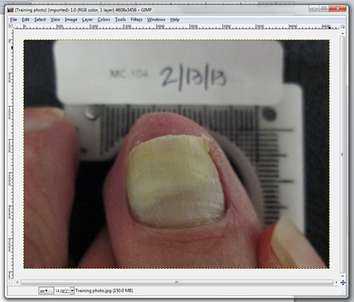
Change the default value from pixels to millimeters (in the lower left corner of the interface) | 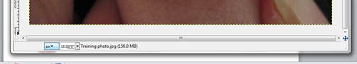  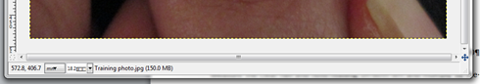
Using the measure tool, select one of the grids (across the top or on the side).  Click to start the measurement in the center of the first line, move through ten line and click to stop the measurement in the center of the tenth line.  NOTE: The measure tools shows an angle; for side lines use 90 degree, for top lines 0 degree angles.  Note the measured value.  To determine the picture scale ratio divide 10 by the noted value. For this example: 10 / 108.7 = .091 | 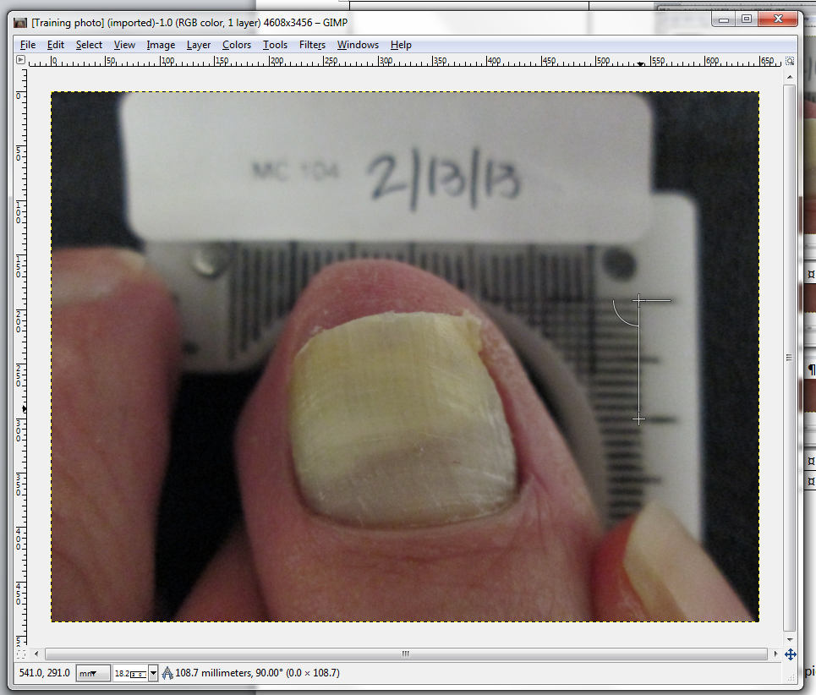
Using the measure tool, measure the length of clear nail from the point of the proximal nail fold to the point of most proximal portion of dystrophy (as shown).  Note the measured value that is shown in the bottom left hand corner. For this example: 72.9  To calculate the actual value, multiply the recorded value (72.9 mm) by the picture scale ratio (.091)  The result is the amount of clear nail in mm:  72.9 X .091 = 6.63 | 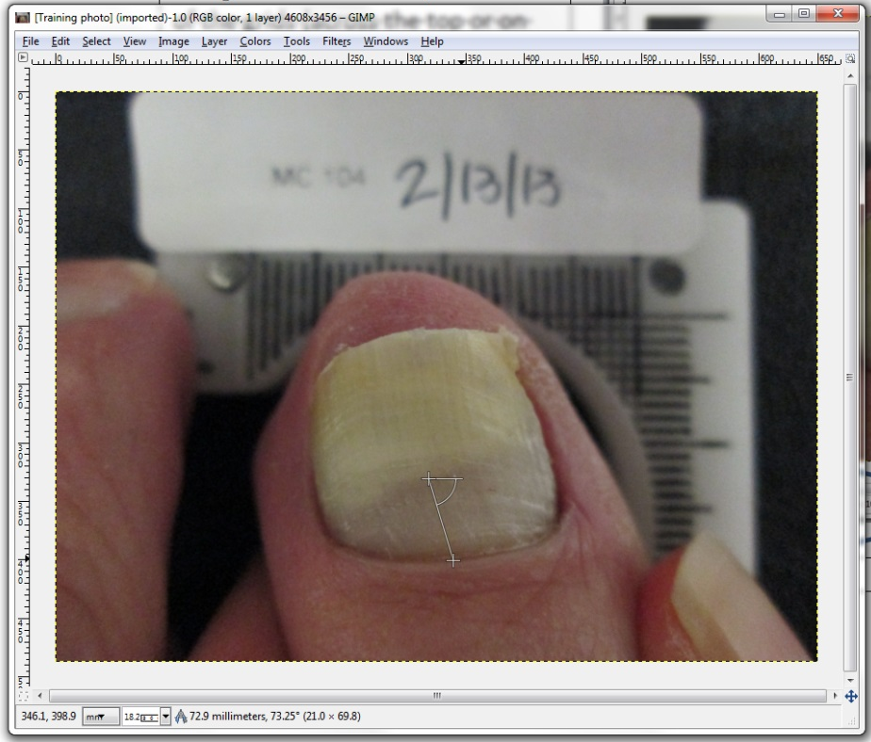

APPENDIX D

RANDOMIZATION SCHEDULES

STUDY INVESTIGATOR EVALUATION OF THE SUCCESS OF THE PROCEDURAL TRAINING OF THE STUDY EVALUATORS: ORDER OF EVALUATION IMAGE PRESENTATION WITHIN AND BETWEEN MEASUREMENT METHODOLOGIES FOR EACH STUDY EVALUATOR

ORDER OF MEASUREMENT METHODOLOGY EVALUATION

Key: 1 = Manual Measurement Methodology
2 = GIMP Measurement Methodology

 | Study Evaluator
Order of Presentation | #1 | #2 | #3
1st | 2 | 1 | 2
2nd | 1 | 2 | 1

MANUAL MEASUREMENT METHODOLOGY EVALUATION ORDER

Images: AA & BB

 | Study Evaluator
Order of Presentation | #1 | #2 | #3
1st | AA | AA | BB
2nd | BB | BB | AA

GIMP MEASUREMENT METHODOLOGY EVALUATION ORDER

Images: CC & DD

 | Study Evaluator
Order of Presentation | #1 | #2 | #3
1st | DD | CC | CC
2nd | CC | DD | DD

STUDY EVALUATOR STUDY PHOTOGRAPHIC SET EVALUATION:
ORDER OF EVALUATION IMAGE PRESENTATION WITHIN AND BETWEEN
STUDY EVALUATORS AND MEASUREMENT METHODOLOGIES

ORDER OF MEASUREMENT METHODOLOGY EVALUATION

Key: 1 = Manual Measurement Methodology
2 = GIMP Measurement Methodology

 | Study Evaluator
Order of Presentation | #1 | #2 | #3
1st | 1 | 2 | 1
2nd | 2 | 1 | 2

STUDY EVALUATOR STUDY PHOTOGRAPHIC SET EVALUATION:
ORDER OF EVALUATION IMAGE PRESENTATION WITHIN AND BETWEEN
STUDY EVALUATORS AND MEASUREMENT METHODOLOGIES

MANUAL MEASUREMENT METHODOLOGY EVALUATION: IMAGE PRESENTATION ORDER

 | Study Evaluator
Order of Presentation (Photograph Number) | #1 | #2 | #3
1 | R | P | J
2 | L | H | D
3 | E | G | T
4 | B | T | P
5 | H | J | K
6 | F | C | R
7 | P | B | F
8 | G | E | S
9 | N | S | H
10 | J | K | B
11 | S | N | G
12 | M | M | M
13 | O | D | L
14 | T | Q | Q
15 | K | R | A
16 | Q | O | N
17 | A | I | O
18 | C | F | I
18 | D | A | C
20 | I | L | E

STUDY EVALUATOR STUDY PHOTOGRAPHIC SET EVALUATION:
ORDER OF EVALUATION IMAGE PRESENTATION WITHIN AND BETWEEN
STUDY EVALUATORS AND MEASUREMENT METHODOLOGIES

GIMP 2.8 MEASUREMENT METHODOLOGY EVALUATION: IMAGE PRESENTATION ORDER

 | Study Evaluator
Order of Presentation (Photograph Number) | #1 | #2 | #3
1 | K | P | C
2 | R | H | E
3 | D | S | N
4 | L | D | I
5 | B | G | G
6 | N | B | L
7 | P | N | P
8 | S | A | K
9 | H | I | T
10 | M | Q | A
11 | I | J | R
12 | O | E | H
13 | G | C | Q
14 | C | L | M
15 | T | R | D
16 | F | K | S
17 | J | M | J
18 | E | O | O
18 | Q | F | F
20 | A | T | B

APPENDIX D

GIMP 2.8 SOFTWARE
VALIDATION STUDY
RESULTS

RESULTS REPORT FOR:

A Validation Protocol for Application of the
GNU Image Manipulation Program (GIMP 2.8)
to the Measurement of
mm of Clear Nail on Toenails

ERCHONIA CORPORATION

Version 2.0
April 24, 2015

Results analysis performed on June 15, 2015

TABLE OF CONTENTS

STUDY INFORMATION 1
SPONSOR 1
CLINICAL CONSULTANT 1
STUDY INVESTIGATOR 1
STUDY EVALUATORS 1
TEST SITE 1
STUDY OBJECTIVE 1
FDA RESOURC ES UTILIZED 1
STUDY DESIGN AND PROCEDURES 2
SAMPLE 2
MEASUREMENT METHODOLOGIES AND TOOLS 2
STUDY INVESTIGATOR 2
STUDY EVALUATORS 2
STUDY PROCEDURES 3
STUDY INVESTIGATOR ACTIVITIES 3
STUDY EVALUATOR ACTIVITIES 4
TRAINING EVALUATION RESULTS 5
STATISTICAL ANALYSIS RESULTS 6
PRIMARY OUTCOME EVALUATION 6
SECONDARY OUTCOME EVALUATIONS 7
CONCLUSION 9

APPENDICES
APPENDIX A: INDIVIDUAL MEASUREMENTS OF THE 20 PHOTOGRAPH STUDY EVALUATION SET BY MEASUREMENT METHODOLOGY BY STUDY EVALUATOR
APPENDIX B: PHOTOGRAPH SET USED FOR MEASUREMENT METHODOLOGY TRAINING AND TRAINING SUCCESS EVALUATION
APPENDIX C: PHOTOGRAPH SET USED FOR VALIDATION EVALUATION

STUDY INFORMATION

SPONSOR
Erchonia Corporation
McKinney, TX 75069
Contact: Mr. Steven Shanks, President
Telephone: 214-544-2227
e-mail: sshanks@erchonia.com

CLINICAL CONSULTANT
Regulatory Insight, Inc., Nashville Office
Brentwood TN 37027
Contact: Elvira Walls, Clinical Consultant
Telephone: 615-712-9743
e-mail: elvira@reginsight.com

STUDY INVESTIGATOR
Kerry Zang, DPM
Arizona Institute of Footcare Physicians
Mesa, AZ 85204
Telephone: 480-834-8804
e-mail: kerryzang@aol.com

STUDY EVALUATORS

1. Shah Askari, DPM

2. Sue Erredge, DPM

3. Mia Horvath, DPM

TEST SITE
St. Luke’s Hospital
Phoenix, Arizona 85006
Telephone: 602-251-8100

STUDY OBJECTIVE
The objective of this study was to validate the GNU Image Manipulation Program (GIMP 2.8) for the measurement of mm of clear nail from the proximal nail fold to the most proximal area of nail dystrophy from digital photographs of onychomycosis infected great toenails for the purpose of results analysis of clinical trial data evaluating the treatment effect of low level laser therapy on toenail onychomycosis, whose results are intended to support a 510(k) submission.

FDA RESOURCES UTILIZED
This validation study protocol was evaluated by the FDA through the Q-Submission review process under Q150259 under the leadership of:
- LT Atiq Chowdhury, M.S., Biomedical Engineer &Lead Reviewer
General Surgery Devices Branch I (GSDB1)
Division of Surgical Devices (DSD); Office of Device Evaluation (ODE)
Center for Devices and Radiological Health (CDRH)
Food and Drug Administration; U.S. Public Health Service
Telephone: 301-796-6391
e-mail: atiq.chowdhury@fda.hhs.gov

Detailed Study Information and Background and Study Objective information can be found on pages 1 to 3 of the accompanying Validation Study protocol.
STUDY DESIGN & PROCEDURES

This Validation Study was a blinded randomized evaluation of a set of 20 digital photographs of great toenails with varying degrees of onychomycosis involvement employing two different measurement methodologies and three independent Study Evaluators.

SAMPLE
The sample in this validation study comprised 20 photographs of onychomycosis-involved great toenails selected from amongst an existing pool of photographs taken as part of prior research studies. Photographs were selected such that entire range of per cent of onychomycosis involvement (full range of diseases severity) from <5% to >95% was evenly represented.

The selected photographic set used in this Validation Study is contained in Appendix B of this Results Analysis Report.

MEASUREMENT METHODOLOGIES AND TOOLS
Measurement of the distance of the straight line formed between the point of proximal nail fold to the point of most proximal portion of dystrophy on the great toenail in each digital photograph in the mm scale recording device in which the nail was placed and photographed was recorded according to both of the following two measurement methodologies, using the associated tools.

- Manual Measurement Methodology Employing Application of a Manual Ruler: Measurement of mm of clear nail for each digital photograph was made using a manual mm marked straight-line ruler according to the procedural methodology contained in Appendix B of the accompanying Validation Study protocol.

- GIMP 2.8 Measurement Methodology Employing Application of the GNU Image Manipulation Program (GIMP 2.8): Measurement of mm of clear nail from each digital photograph was also made using GIMP 2.8 system software according to the procedural methodology contained in Appendix C of the accompanying Validation Study protocol.

STUDY INVESTIGATOR
The Study Investigator was a Board Certified Podiatrist (DPM) with a current clinical practice license and experienced in the diagnosis, assessment and treatment of toenail onychomycosis. The Study Investigator was responsible for oversight of the validation study, including selection of the study photo set, and the procedural training and evaluation of the three independent study evaluators.

STUDY EVALUATORS
There were three Study Evaluators in this validation study who were Board Certified Podiatrists (DPMs) with current clinical practice licenses and experienced in the diagnosis, assessment and treatment of toenail onychomycosis.

STUDY PROCEDURES

STUDY INVESTIGATOR ACTIVITIES

The progressive order of Study Investigator activities in this study was as follows:

- Study Photograph Set Selection: The Study Investigator selected the set of 20 study photographs to be evaluated in the validation study from the full set of available photographs according to the following pre-specified qualification criteria.

Inclusion Criteria
- Great toenail presents with clearly visually identifiable and photographically documentable onychomycosis of the great toenail, or no visible onychomycosis (1 great toenail)
- Onychomycosis has been identified as due to bacterial/fungal infection classified by the investigator as onychomycosis, with the nail presenting positive on visual inspection for somewhat thickened nail plate with a cloudy appearance and some discoloration (white to yellow to brown)
- Onychomycosis etiology has been confirmed through positive fungal KOH testing results

Exclusion Criteria
- The category of the presenting visible great toenail onychomycosis (0%-25% onychomycosis involvement; 26%-50% onychomycosis involvement; 51%-75% onychomycosis involvement; 76%-100% onychomycosis involvement) has already met the quota of 5 qualified enrolled great toenails
- Spikes of disease extending to nail matrix in the great toenail
- Infection involving lunula of the great toenail, e.g. genetic nail disorders, primentary disorders
- Great toenail has less than 2mm clear (unaffected) nail plate length beyond the proximal fold
- Dermatophytoma or “yellow spike/streak” (defined as thick masses of fungal hyphae and necrotic keratin between the nail plate and nail bed) on the great toenail
- Onychogryphosis
- Proximal subungual onychomycosis
- White superficial onychomycosis

The selected photographic set used in this Validation Study is contained in Appendix C of this Results Analysis Report.

- Procedural Training and Evaluation of Study Evaluators:

- Procedural Training of Study Evaluators: The Study Investigator trained the three Study Evaluators on application of both the manual measurement methodology and the GIMP 2.8 measurement methodology using a single photo sample that was not a part of the 20 study photograph set.

The Manual Measurement Methodology instruction sheet and the GIMP 2.8 Measurement Methodology instruction sheet to which the Study Evaluators were trained by the Study Investigator is contained in Appendix B and Appendix C, respectively, of the accompanying Validation Study protocol.

- Procedural Training Evaluation of Study Evaluators: Following training to both measurement methodologies, the Study Investigator performed an evaluation of training success. Each Study Evaluator was independently provided with 4 photographs of great toenails with differing degrees of onychomycosis involvement: The four photographs were presented to each of the 3 Study Evaluators in individually randomized photographic and evaluation methodology order, as contained in Appendix D of the accompanying Validation Study protocol. Two of the photographs were measured by the Study Evaluators for the mm of clear nail by applying the manual measurement methodology, and the other two by applying the GIMP 2.8 measurement methodology.

Training success criteria of a Study Evaluator was pre-established as a Study Evaluator’s measurements being within 1 mm of that measured by the Study Investigator. Rationale for establishment of the 1 mm pre-determined cut-off value is explained in detail in the Statistical Analysis Plan section of the accompanying Validation Study protocol.

The training and training evaluation photographs used in this Validation Study are contained in Appendix B of this Results Analysis Report.

STUDY EVALUATOR ACTIVITIES

- Study Photographic Set Evaluation: Following successful completion of the training phase, each of the three Study Evaluators evaluated the study photographic set, according to the procedural protocol and methodologies for both the manual measurement and GIMP 2.8 measurement techniques, and according to the randomized order of presentation described in the Study Design section and Appendix D of the accompanying Validation Study protocol. Each Study Evaluator performed this process and these functions independently of each other.

More detailed Study Design and Study Procedures information can be found on pages 4 to 10 of the accompanying Validation Study protocol.

TRAINING EVALUATION RESULTS

As per the ‘Procedural Training Evaluation of Study Evaluators’ section contained on page 10 of the accompanying Validation Study protocol, all of the three Study Evaluators’ measurements of mm of clear nail of the two photographs measured employing the manual measurement methodology and the two photographs measured using the GIMP 2.8 measurement methodology were within 1 mm of the corresponding measurements made by the Study Investigator. Therefore, training efficacy evaluation was established at initial evaluation for all three Study Evaluators, and as such, all were qualified to proceed to the study photographic set evaluation phase of the study.

Table 1 below shows the mm of clear nail measurements made by the Study Investigator and each of the three Study Evaluators and the relative difference between the two for all 4 training evaluation photographs and both measurement methodologies.

Table 1: mm clear nail measurements for training evaluation photographs

 |  |  | Study Evaluator #1 |  | Study Evaluator #2 |  | Study Evaluator #3
Measure- ment Method | Photo | Study Investigator  (mm) | mm | Difference from Study Investigator | mm | Difference from Study Investigator | mm | Difference from Study Investigator
Manual | AA | 7.0 | 7.0 | 0.0 | 7.0 | 0.0 | 6.5 | 0.5
Manual | BB | 11.0 | 11.5 | 0.5 | 11.0 | 0.0 | 11.0 | 0.0
GIMP | CC | 8.3 | 8.0 | 0.3 | 8.2 | 0.1 | 8.1 | 0.2
GIMP | DD | 10.7 | 10.8 | 0.1 | 10.4 | 0.3 | 9.7 | 1.0

STATISTICAL ANALYSIS RESULTS

PRIMARY OUTCOME EVALUATION
Primary outcome evaluation of successful validation of the application of the GIMP 2.8 measurement methodology to measuring mm of clear nail from digital images of onychomycosis involved great toenails was pre-determined to be through the following means:

- Per Nail Success Criterion: Within Individual Evaluators:The per nail success criterion was pre-defined in relation to an objective cut-off per nail of one (1) mm between the mm of clear nail measurement calculated using the manual mm ruler measurement method and the GIMP 2.8 software measurement method for the same great toenail digital image for each of the three independent Study Evaluators. That is, the maximal tolerated difference between the two measurement techniques that would render the two measurements the same was pre-determined as 1 mm.

Rationale and justification for pre-determination of the per nail success criterion cut-off of 1 mm is contained in the Statistical Analysis Plan section on page 11 of the accompanying Validation Study protocol.

It was pre-established that a minimum 60% percent of nails were required to meet the per-nail success criterion in order to satisfy this validation criterion.

Table 2 below shows the percentage of Study Evaluator measured great toenails that met the per nail success criterion cut-off of no greater than 1 mm difference between the manual and GIMP methodology measurements for the same toenail by the same Study Evaluator.

Table 2: Per cent per nail success criterion met by individual study evaluator

 | Number Meeting Per-Nail Success | % Meeting Per-Nail Success
Evaluator #1 | 13/20 | 65%
Evaluator #2 | 15/20 | 75%
Evaluator #3 | 17/20 | 85%
All Evaluators | 45/60 | 75%
Therefore, in consideration of the measurements of all three independent Study Evaluators combined, the attained study success rate of 75% exceeds the pre-established study success criterion rate of 60% by 15%.

Similarly, on the individual Study Evaluator level, the per-nail success rate attained by each of the three independent Study Evaluators exceeds the pre-established study success criterion by 5% (Study Evaluator #1); 15% (Study Evaluator #2) and 25% (Study Evaluator #3).

- Per Nail Success Criterion: Between/Across Evaluators: Agreement in mm of clear nail measurements amongst two of the three blinded evaluators with respect to the pre-defined minimally acceptable difference was pre-determined to be sufficient for accepting the results as supportive of validation of the measurement tool being evaluated.

Table 3 below shows the mm measurements recorded by each of the three independent Evaluators using both the manual measurement and the GIMP 2.8 measurement methodologies for each of the 20 photo images evaluated.

Table 3: Individual study evaluator manual and GIMP 2.8 image measurements
 | MANUAL MEASUREMENT METHODOLOGY (mm) |  |  | GIMP 2.8 MEASUREMENT METHODOLOGY (mm)
PHOTO  IMAGE | EVALUATOR #1 | EVALUATOR #2 | EVALUATOR #3 | EVALUATOR #1 | EVALUATOR #2 | EVALUATOR #3
A | 4.0 | 4.0 | 3.5 | 3.7 | 3.80 | 3.4
B | 8.5 | 10.0 | 8.0 | 8.8 | 8.62 | 8.5
C | 3.5 | 4.0 | 3.5 | 3.7 | 4.36 | 3.6
D | 11.5 | 12.5 | 11.5 | 11.7 | 12.21 | 11.9
E | 5.0 | 5.0 | 4.5 | 5.2 | 5.31 | 4.9
F | 4.5 | 5.0 | 4.5 | 4.4 | 5.15 | 4.3
G | 10.0 | 12.0 | 10.0 | 10.6 | 10.15 | 10.3
H | 5.0 | 5.0 | 5.0 | 5.3 | 5.45 | 5.5
I | 20.0 | 16.0 | 15.0 | 16.0 | 15.60 | 15.1
J | 10.5 | 12.0 | 11.0 | 10.9 | 11.84 | 10.4
K | 13.0 | 14.5 | 13.5 | 15.0 | 14.17 | 13.3
L | 6.0 | 5.5 | 6.5 | 7.8 | 11.74 | 11.1
M | 21.5 | 22.0 | 22.0 | 21.8 | 22.51 | 21.5
N | 8.0 | 8.0 | 7.5 | 8.0 | 7.99 | 7.7
O | 7.0 | 7.5 | 5.0 | 5.9 | 7.26 | 6.3
P | 17.0 | 18.0 | 17.5 | 12.5 | 18.30 | 16.9
Q | 4.0 | 4.0 | 4.0 | 5.9 | 4.69 | 4.5
R | 12.5 | 13.0 | 13.5 | 14.6 | 14.76 | 14.7
S | 2.5 | 11.0 | 3.0 | 3.1 | 14.36 | 3.5
T | 11.0 | 11.5 | 10.5 | 10.9 | 12.12 | 10.8

With application of the criteria of two of the three evaluators needing to attain consensus on the mm of clear nail measurement to within the minimally acceptable difference of 1 mm, then there are no instances in which this criteria is not met for the manual measurement methodology, and there is only one instance (Sample P) in which this criteria is not met for the GIMP 2.8 measurement methodology, as highlighted above in Table 3. In Sample P, the difference was only slightly more than the 1mm criteria at 1.4mm.

Therefore, overall, based on the pre-established primary outcome evaluation criteria, this validation study is considered a success with respect to establishment of successful validation of the application of the GIMP 2.8 measurement methodology to measuring mm of clear nail from digital images of onychomycosis involved great toenails.

SECONDARY OUTCOME EVALUATIONS

The following pre-established secondary evaluations were also performed on the data collected:

- Comparison of the median (the middle of the three manual ruler measurements and the middle of the three measurements made using the GIMP 2.8 software method) values was made as a supportive evaluation of the primary outcome analysis. Median values that differed by no more than the pre-established cut-off of 1 mm (as defined and supported in the PRIMARY OUTCOME EVALUATION section above), then the two measurements were considered the same.

Employing this analysis methdology, 18 of the 20 nail measurements met the pre-established 1 mm cut-off study success criterion when comparing the median manual measurement value to the median GIMP measurement value for the same digital image. This 90% success rate exceeds the pre-established success rate criterion of 60% by 30%.

- Pearson Product-Moment Correlation Co-efficient Analysis was performed to measure the strength and direction of the linear relationship between the mm of clear nail measurements made using the manual measurement method and the mm of clear nail measurements made using the GIMP 2.8 measurement method for each of the same 20 digital photograph great toenail images within and across all three independent Study Evaluators.

Table 4 below shows the Pearson Product-Moment Correlation Co-efficient (r) results for the relationship between mm measurements attained using the manual versus the GIMP measurement methodology for the same digital photograph by the same Study Evaluator for each individual Evaluator and across all Evaluators.

Table 4: Correlation of mm measurements between measurement methodologies by Study Evaluator

 | n | r
Evaluator #1 | 20 | 0.95
Evaluator #2 | 20 | 0.94
Evaluator #3 | 20 | 0.98
All Evaluators | 60 | 0.96

The Pearson Product-Moment Correlation Co-efficient (r) ranges from -1.0 to +1.0. An ‘r’ value of -1.0 indicates total negative in opposite directions) correlation between the two measures; an ‘r’ value of 0 indicates no correlation (no relationship at all) between the two measures; and an ‘r’ value of +1.0 indicates a total positive (same direction) correlation between the two measures

From Table 4 above, it can be seen that for the study overall, and at the individual Study Evaluator level, the correlation between the mm measurements made for a particular digital photgraphic image using the manual measurement methodology nearly perfectly and positively correlated with the mm measurement made for the same digital photographic image using the GIMP 2.8 measurement methodology independent of Study Evalautor.

- T-test analysis for two independent samples was performed to evaluate differences in the mm of clear nail measurement made by each of the three independent Study Evaluators comparing the measurements attained using the manual measurement method versus the GIMP 2.8 measurement method for each evaluator.

There was no statistically significant difference found between the measurements attained using the manual measurement methodology versus the measurements attained using the GIMP 2.8 measurement methodology for the same 20 relative digital images for any of the three independent Study Evaluator, or summed across all three Study Evaluators, as shown in Table 5 below:

Table 5: T-test analysis results for methodological measurement differences by Study Evaluator
 | n | Mean Difference | t | df | p(2-tailed) | Significance
Evaluator #1 | 20 | 0.04 | +0.02 | 38 | 0.98 | p>0.05
Evaluator #2 | 20 | 0.49 | +0.3 | 38 | 0.77 | p>0.05
Evaluator #3 | 20 | 0.435 | +0.26 | 38 | 0.80 | p>0.05
All Evaluators | 60 | 0.32 | +0.34 | 118 | 0.73 | p>0.05

- ANOVA analysis for three indepenedent samples was performed to evaluate differences in the mm of clear nail measurement made by each of the three Study Evaluators for the same digital image when using the manual measurement method and when using the GIMP 2.8 measurement method.

There was no statistically significant difference found between the three independent Study Evaluator measurements of the 20 photographic images using either the manual measurement or the GIMP 2.8 measurement methodologies, as follows:

- Manual Measurement Methodology: F=0.21; p=0.81; p>0.05
- GIMP 2.8 Measurement Methodology: F=0.35; p=0.70; p>0.05

- Intraclass correlation co-efficient (ICC) analysis was used to evaluate consistency or reproducibility of the mm of clear nail measurements for the same digital photographic set made between the three independent Study Evaluators.

ICC analysis is applied in this study as a measurement of the strength of the scalar agreement or concordance between the two evaluable variables. An ICC value of ‘0‘ indicates there is no agreement or concordance at all between the two measures, while and ICC value of ‘1‘ indicates perfect agreement or concordance between the two measures. Specifically, the categories of ICC values and the associated indicated agreements are as follows:

ICC Value Range | Agreement
0 - 0.2 | Poor
0.3 – 0.4 | Fair
0.5 – 0.6 | Moderate
- – 0.8 | Strong
> 0.8 | Almost perfect

It was pre-determined for the purposes of analysis of the results of this Validation Study that an ICC value greater than 0.7 would be considered indicative of strong agreement between ratings and positive for demonstrating validation of intra-variation between and within Study Evaluators, respectively.

Tables 6 and 7 below show the Intraclass correlation co-efficient (ICC) analysis results for the measurement of scalar agreement as an indication of consistency or reproducibility of the mm of clear nail measurements for the same digital photographic set made between and across the three independent Study Evaluators.

Table 6: ICC results for measurement agreement differences between study evaluators
 | ICC | Agreement Category | Agreement Interpretaion
GIMP measurements between the 3 Study Evaluators | 0.89 | > 0.8 | Almost perfect agreement
Manual measurements between the 3 Study Evaluators | 0.94 | > 0.8 | Almost perfect agreement
GIMP & Manual measurements between the 3 Study Evaluators | 0.91 | > 0.8 | Almost perfect agreement

Therefore, the mm of clear nail measurements made using both the GIMP 2.8 measurement methodology and the manual measurement methodology, whether consideration separately or in combination, are in almost perfect agreement amongst the three Study Evaluators for the same study set of 20 digital image great toenail onychomycosis involved photographs

Table 7: ICC results for measurement agreement differences between GIMP and manual measurements by Study Evaluator
 | ICC | Agreement Category | Agreement Interpretaion
Evaluator #1 | 0.95 | > 0.8 | Almost perfect agreement
Evaluator #2 | 0.94 | > 0.8 | Almost perfect agreement
Evaluator #3 | 0.975 | > 0.8 | Almost perfect agreement

Therefore, the mm of clear nail measurements made using both the GIMP 2.8 measurement methodology and the manual measurement methodology for the same study set of 20 digital image great toenail onychomycosis involved photographs by each of the three individual Study Evaluators are in almost perfect agreement.

CONCLUSION: In consideration of all of the above primary and secondary outcome findings, all are highly significant and supportive of the study objective to validate the GNU Image Manipulation Program (GIMP 2.8) for the measurement of mm of clear nail from the proximal nail fold to the most proximal area of nail dystrophy from digital photographs of onychomycosis infected great toenails for the purpose of results analysis of clinical trial data evaluating the treatment effect of low level laser therapy on toenail onychomycosis, whose results are intended to support a 510(k) submission for the indication off treatment of onychomycosis.

Therefore, it can be concluded that the GNU Image Manipulation Program (GIMP 2.8) is validated for the measurement of mm of clear nail from the proximal nail fold to the most proximal area of nail dystrophy from digital photographs of onychomycosis infected great toenails.

APPENDIX A

INDIVIDUAL MEASUREMENTS OF THE 20 PHOTOGRAPH STUDY EVALUATION SET BY MEASUREMENT METHODOLOGY BY STUDY EVALUATOR

The table below contains the individual mm measurements made from the set of 20 digital photographic images in the validation set by each of the three Study Evaluators employing both the manual and GIMP 2.8 measurement methodologies.

 | MANUAL MEASUREMENT METHODOLOGY (mm) |  |  | GIMP 2.8 MEASUREMENT METHODOLOGY (mm)
PHOTO  IMAGE | EVALUATOR #1 | EVALUATOR #2 | EVALUATOR #3 | EVALUATOR #1 | EVALUATOR #2 | EVALUATOR #3
A | 4.0 | 4.0 | 3.5 | 3.7 | 3.80 | 3.4
B | 8.5 | 10.0 | 8.0 | 8.8 | 8.62 | 8.5
C | 3.5 | 4.0 | 3.5 | 3.7 | 4.36 | 3.6
D | 11.5 | 12.5 | 11.5 | 11.7 | 12.21 | 11.9
E | 5.0 | 5.0 | 4.5 | 5.2 | 5.31 | 4.9
F | 4.5 | 5.0 | 4.5 | 4.4 | 5.15 | 4.3
G | 10.0 | 12.0 | 10.0 | 10.6 | 10.15 | 10.3
H | 5.0 | 5.0 | 5.0 | 5.3 | 5.45 | 5.5
I | 20.0 | 16.0 | 15.0 | 16.0 | 15.60 | 15.1
J | 10.5 | 12.0 | 11.0 | 10.9 | 11.84 | 10.4
K | 13.0 | 14.5 | 13.5 | 15.0 | 14.17 | 13.3
L | 6.0 | 5.5 | 6.5 | 7.8 | 11.74 | 11.1
M | 21.5 | 22.0 | 22.0 | 21.8 | 22.51 | 21.5
N | 8.0 | 8.0 | 7.5 | 8.0 | 7.99 | 7.7
O | 7.0 | 7.5 | 5.0 | 5.9 | 7.26 | 6.3
P | 17.0 | 18.0 | 17.5 | 12.5 | 18.30 | 16.9
Q | 4.0 | 4.0 | 4.0 | 5.9 | 4.69 | 4.5
R | 12.5 | 13.0 | 13.5 | 14.6 | 14.76 | 14.7
S | 2.5 | 11.0 | 3.0 | 3.1 | 14.36 | 3.5
T | 11.0 | 11.5 | 10.5 | 10.9 | 12.12 | 10.8

APPENDIX B

PHOTOGRAPH SET USED FOR MEASUREMENT METHODOLOGY TRAINING AND TRAINING SUCCESS EVALUATION

The image below contains the digital photographic image that was used in the Validation Study by the Study Investigator to train the three independent Study Evaluators to application of both the manual measurement and the GIMP 2.8 measurement methodologies with respect to measurement of mm of clear nail from the proximal nail fold to the point of most proximal portion of dystrophy on the great toenail from like digital images of onychomycosis-infected great toenails.

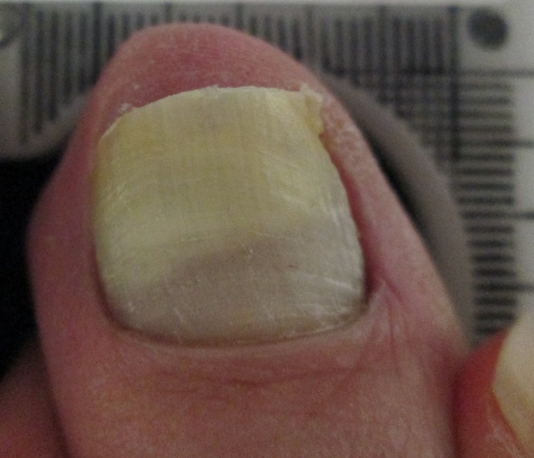

The images below contain the digital photographic images that were used in the Validation Study to evaluate training success for each of the three independent Study Evaluators to application of both the manual measurement and the GIMP 2.8 measurement methodologies with respect to measurement of mm of clear nail from the proximal nail fold to the point of most proximal portion of dystrophy on the great toenail from like digital images of onychomycosis-infected great toenails.

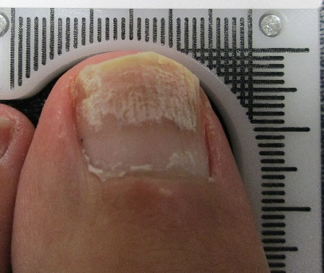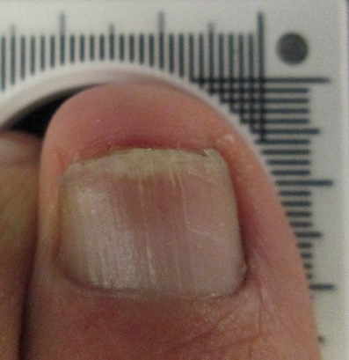
Digital Image AA Digital Image BB

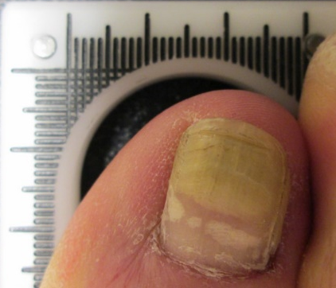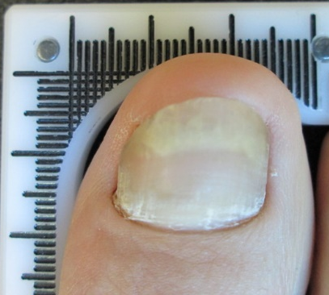
Digital Image CC Digital Image DD

APPENDIX C

PHOTOGRAPH SET USED FOR

VALIDATION EVALUATION

The images below contain the set of 20 digital photographic images of onychomycosis-infected great toenails that were used in the validation evaluation phase of the Validation Study.

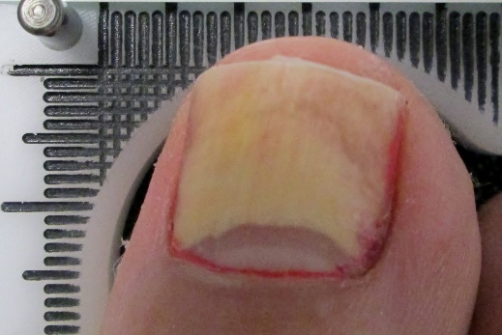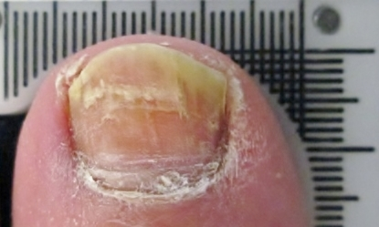
A B

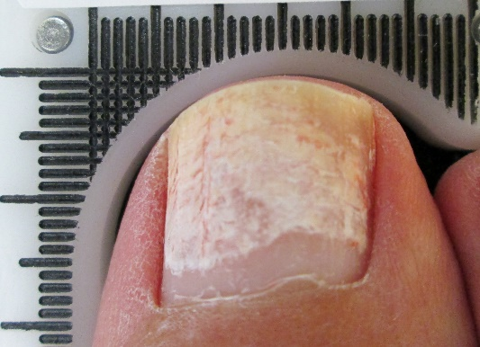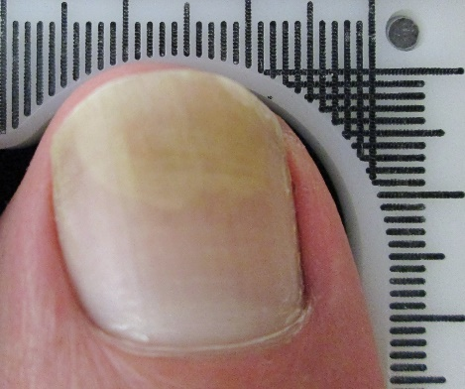
C D

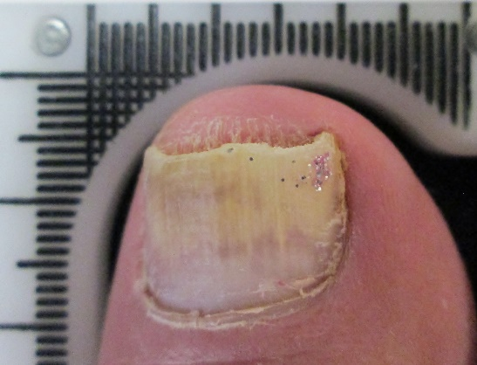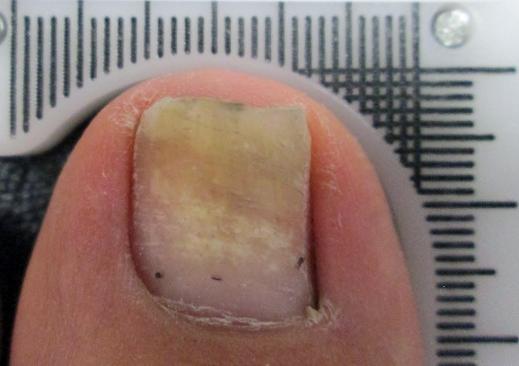
E F
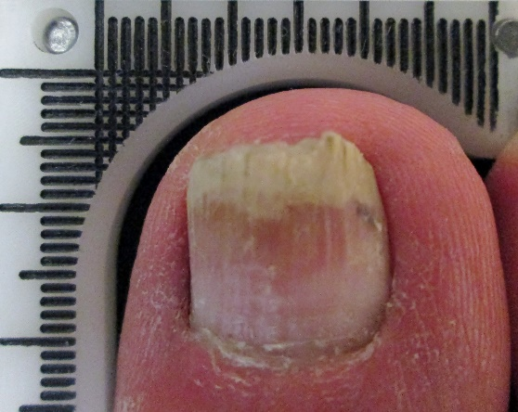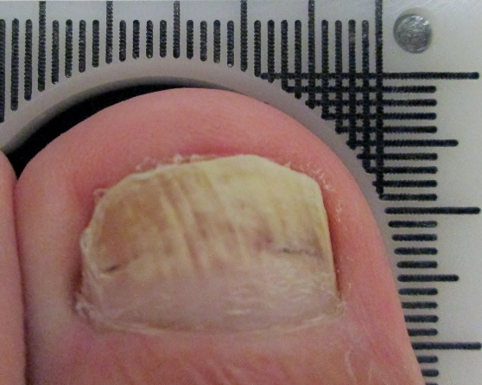
G H

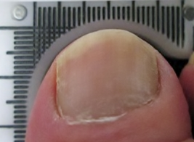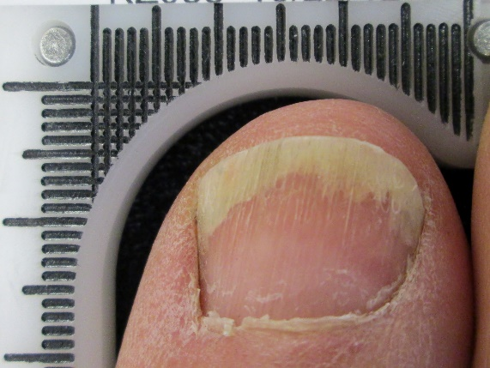
I J

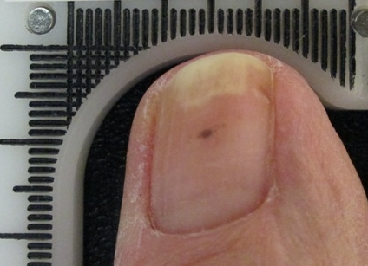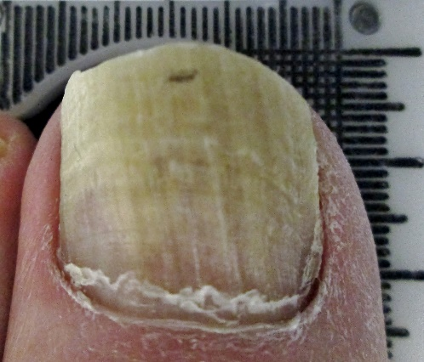
K L

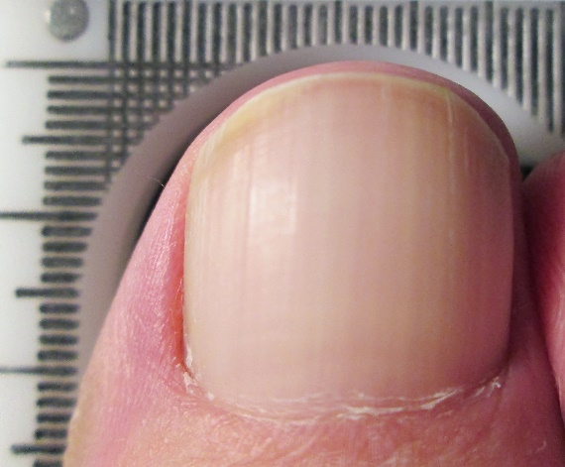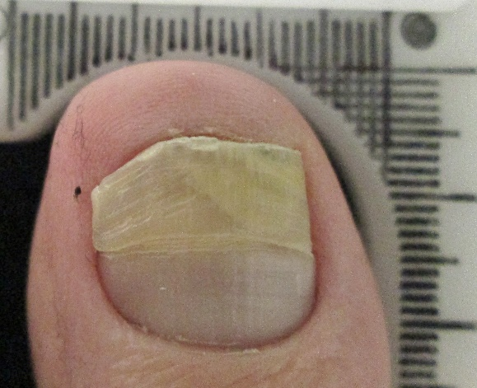
M N

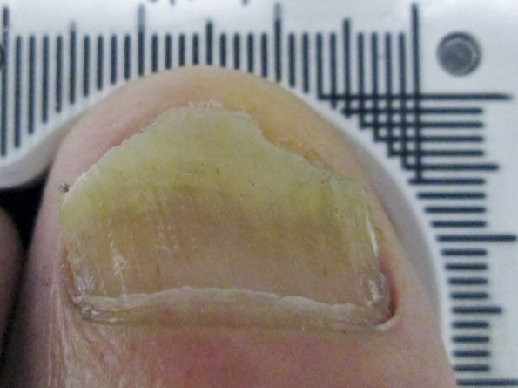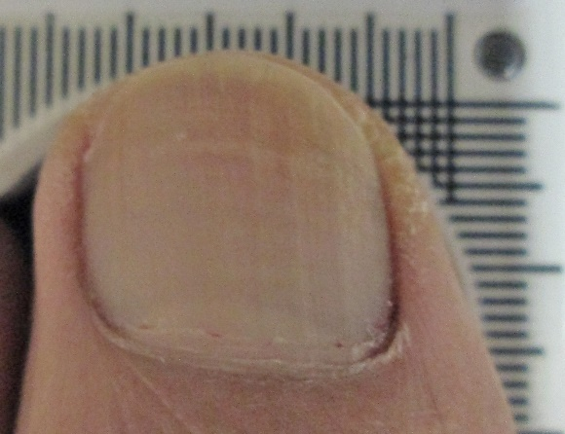
O P
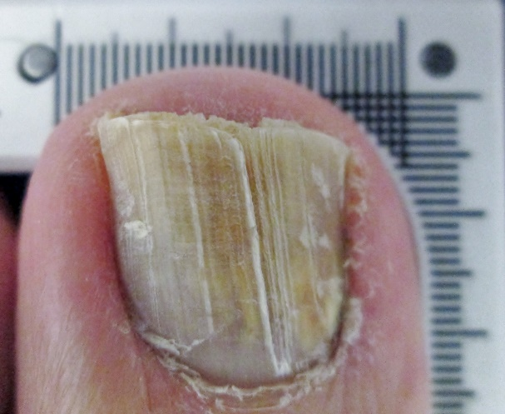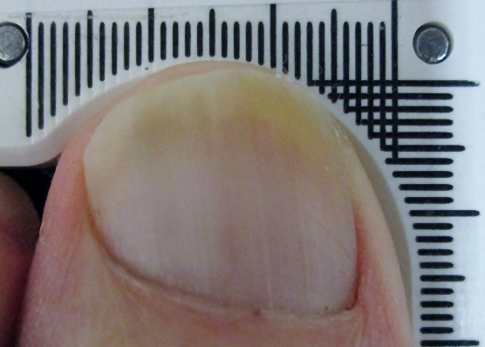
Q R

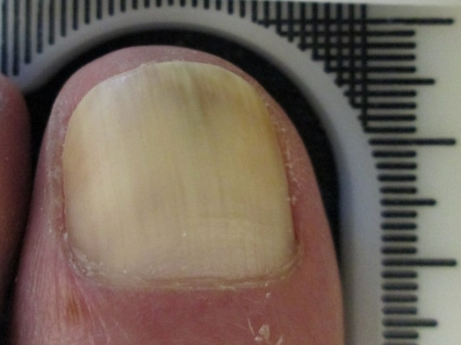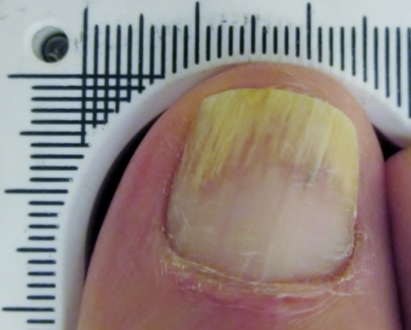
S T

APPENDIX E

GIMP 2.8 MEASUREMENT

METHODOLOGY

INSTRUCTION SHEET

GIMP 2.8 MEASUREMENT METHODOLOGY INSTRUCTION SHEET

TOOLS

- A computer with the GIMP 2.8 software program with digital image(s) of an onychomycosis involved great toenail in the horizontal-vertical mm measurement device

INSTRUCTIONS

Open the image in GIMP software
Change the default value from pixels to millimeters (in the lower left corner of the interface)
Using the measure tool, select one of the grids (across the top or on the side).

Click to start the measurement in the center of the first line, move through ten line and click to stop the measurement in the center of the tenth line.

NOTE: The measure tools shows an angle; for side lines use 90 degree, for top lines 0 degree angles.

Note the measured value.
To determine the picture scale ratio divide 10 by the noted value. For this example: 10 / 108.7 = .091

Using the measure tool, measure the length of clear nail from the point of the proximal nail fold to the point of most proximal portion of dystrophy (as shown).

Note the measured value that is shown in the bottom left hand corner. For this example: 72.9

To calculate the actual value, multiply the recorded value (72.9 mm) by the picture scale ratio (.091)

The result is the amount of clear nail in mm:

72.9 X .091 = 6.63

APPENDIX F

EVALUATOR CODED

PHOTOGRAPH KEY

INVESTIGATOR TOENAIL ONYCHOMYCOSIS INDEPENDENT EVALUATOR
CODED PHOTOGRAPH KEY

Photo ID | Baseline Photo Coded ID | 6 Month Photo Coded ID
A | 200 | 103
B | 061 | 141
C | 033 | 111
D | 197 | 077
E | 053 | 008
F | 128 | 052
G | 032 | 049
H | 153 | 163
I | 104 | 066
J | 092 | 106
K | 134 | 174
L | 014 | 125
M | 048 | 137
N | 169 | 147
O | 190 | 101
P | 098 | 055
Q | 131 | 010
R | 096 | 186
S | 110 | 132
T | 007 | 099
U | 133 | 155
V | 016 | 004
W | 102 | 091
X | 184 | 183
Y | 060 | 071
Z | 050 | 003

Subject ID | Baseline Photo Coded ID | 6 Month Photo Coded ID
AA | 035 | 164
BB | 057 | 179
CC | 037 | 116
DD | 146 | 056
EE | 059 | 088
FF | 108 | 009
GG | 006 | 015
HH | 140 | 162
II | 065 | 120
JJ | 011 | 117
KK | 189 | 195
LL | 043 | 199
MM | 107 | 064
NN | 026 | 182
OO | 112 | 136
PP | 001 | 086
QQ | 031 | 025
RR | 123 | 119
SS | 051 | 085
TT | 095 | 070
UU | 028 | 023
VV | 126 | 084
WW | 165 | 090
XX | 005 | 041
YY | 115 | 018
ZZ | 022 | 193
AAA | 013 | 159
BBB | 002 | 100
CCC | 156 | 067
DDD | 178 | 148
Subject ID | Baseline Photo Coded ID | 6 Month Photo Coded ID
EEE | 121 | 054
FFF | 176 | 171
GGG | 194 | 017
HHH | 160 | 080
III | 158 | 062
JJJ | 177 | 191
KKK | 044 | 087
LLL | 039 | 079
MMM | 151 | 185
NNN | 036 | 114
OOO | 143 | 129
PPP | 135 | 105
QQQ | 045 | 046
RRR | 181 | 047
SSS | 089 | 122
TTT | 124 | 167
UUU | 040 | 187
VVV | 196 | 118
WWW | 144 | 042
XXX | 093 | 082
YYY | 072 | 127
ZZZ | 019 | 058
AAAA | 130 | 012
BBBB | 069 | 024
CCCC | 180 | 068
DDDD | 097 | 073
EEEE | 113 | 075
FFFF | 081 | 157
GGGG | 161 | 074
HHHH | 154 | 030
Subject ID | Baseline Photo Coded ID | 6 Month Photo Coded ID
IIII | 076 | 020
JJJJ | 192 | 038
KKKK | 149 | 078
LLLL | 168 | 027
MMMM | 170 | 109
NNNN | 142 | 172
OOOO | 166 | 198
PPPP | 139 | 029
QQQQ | 034 | 150
RRRR | 138 | 145
SSSS | 175 | 083
TTTT | 173 | 094
UUUU | 188 | 021
VVVV | 152 | 063

APPENDIX G

EVALUATOR PHOTOGRAPH

MEASUREMENT RECORD FORM

RETROSEPCTIVE TOENAIL ONYCHOMYCOSIS STUDY
INVESTIGATOR PHOTOGRAPH MEASUREMENT RECORD FORM

Date of Evaluation: ________/________/_________

Photo ID | Measurement (mm) | Photo ID | Measurement (mm)
001 |  | 023
002 |  | 024
003 |  | 025
004 |  | 026
005 |  | 027
006 |  | 028
007 |  | 029
008 |  | 030
009 |  | 031
010 |  | 032
011 |  | 033
012 |  | 034
013 |  | 035
014 |  | 036
015 |  | 037
016 |  | 038
017 |  | 039
018 |  | 040
019 |  | 041
020 |  | 042
021 |  | 043
022 |  | 044
Photo ID | Measurement (mm) | Photo ID | Measurement (mm)
045 |  | 067
046 |  | 068
047 |  | 069
048 |  | 070
049 |  | 071
050 |  | 072
051 |  | 073
052 |  | 074
053 |  | 075
054 |  | 076
055 |  | 077
056 |  | 078
057 |  | 079
058 |  | 080
059 |  | 081
060 |  | 082
061 |  | 083
062 |  | 084
063 |  | 085
064 |  | 086
065 |  | 087
066 |  | 088

Photo ID | Measurement (mm) | Photo ID | Measurement (mm)
089 |  | 111
090 |  | 112
091 |  | 113
092 |  | 114
093 |  | 115
094 |  | 116
095 |  | 117
096 |  | 118
097 |  | 119
098 |  | 120
099 |  | 121
100 |  | 122
101 |  | 123
102 |  | 124
103 |  | 125
104 |  | 126
105 |  | 127
106 |  | 128
107 |  | 129
108 |  | 130
109 |  | 131
110 |  | 132

Photo ID | Measurement (mm) | Photo ID | Measurement (mm)
133 |  | 155
134 |  | 156
135 |  | 157
136 |  | 158
137 |  | 159
138 |  | 160
139 |  | 161
140 |  | 162
141 |  | 163
142 |  | 164
143 |  | 165
144 |  | 166
145 |  | 167
146 |  | 168
147 |  | 169
148 |  | 170
149 |  | 171
150 |  | 172
151 |  | 173
152 |  | 174
153 |  | 175
154 |  | 176

Photo ID | Measurement (mm) | Photo ID | Measurement (mm)
177 |  | 189
178 |  | 190
179 |  | 191
180 |  | 192
181 |  | 193
182 |  | 194
183 |  | 195
184 |  | 196
185 |  | 197
186 |  | 198
187 |  | 199
188 |  | 200

